**Day 5-Training Word2Vec From Scratch And AvgWord2vec Indepth Inutuition|Krish Naik**

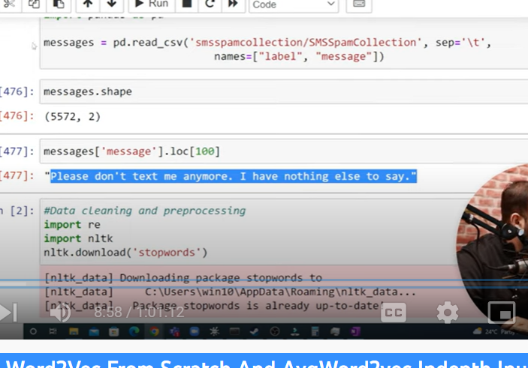

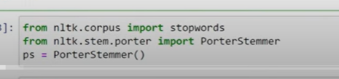

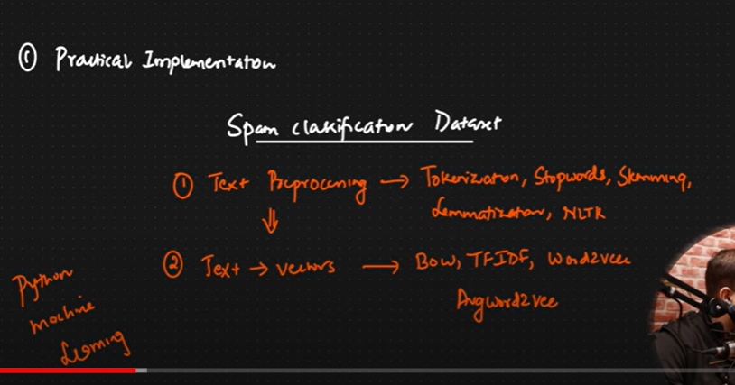

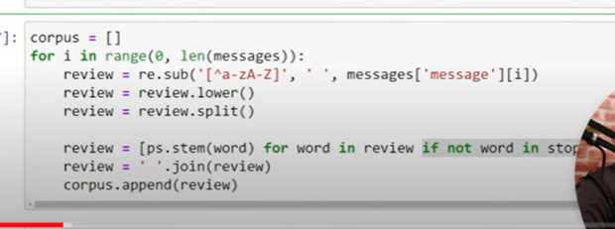

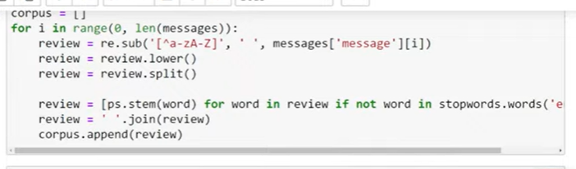

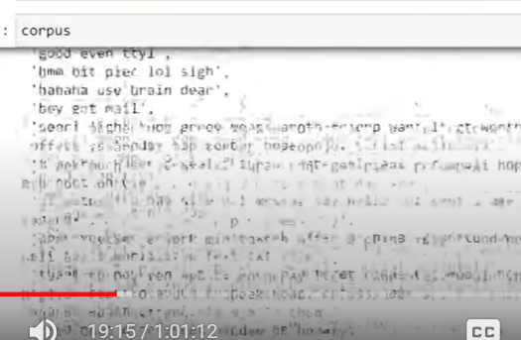

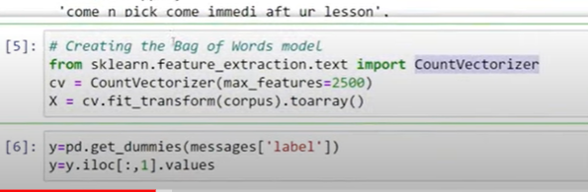

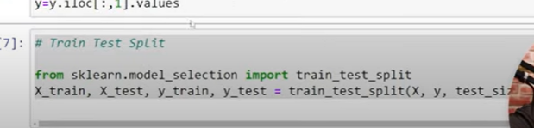

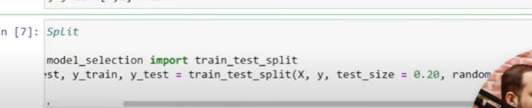

Random state =0

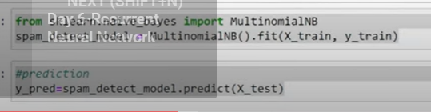

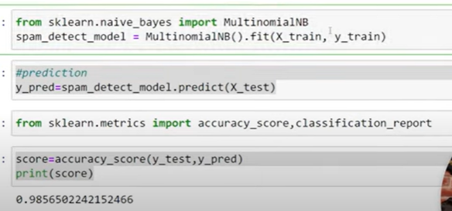

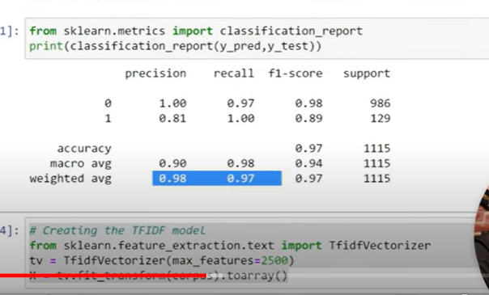

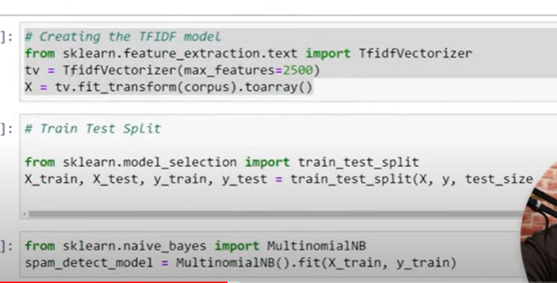

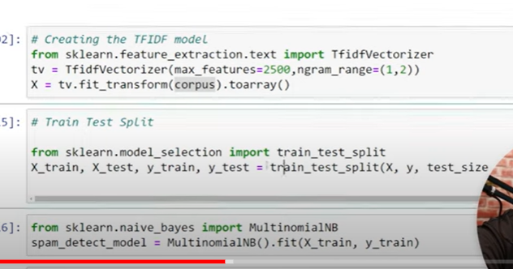

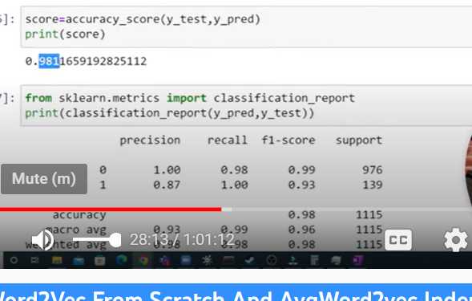

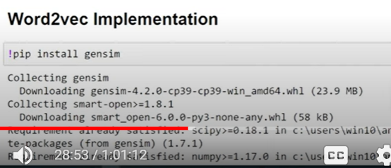

Word2vec

2 types

1. Skip gram
2. cbow

genism library has word2vex

2 types- pre trained

----------- train model from scratch

Should I train model or use trained model?

Based on data set

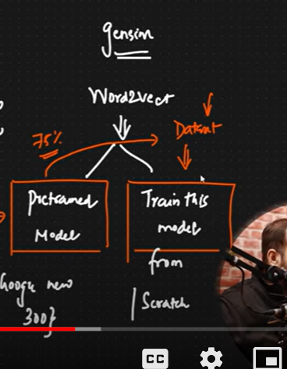

We convert word to fixed size vectors with different dimensions

Each word has 300 dimensions

If sentence has 10 words

Each word into 300 dimensions

300*10

We need to aim that entire sentence should be converted to 300 dimensions

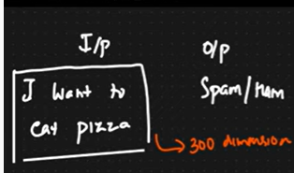

We can fix the [problem – new concept called “average word2vec”

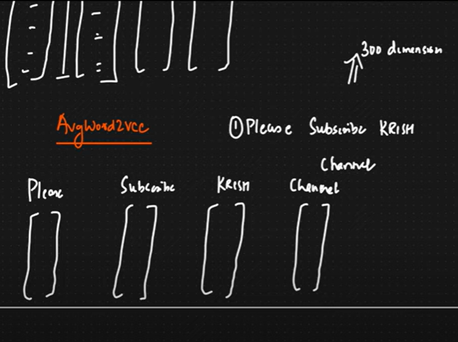

But I want to make it 300 dimension for entire sentence

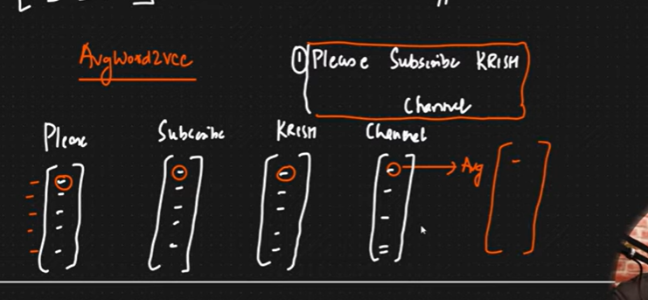

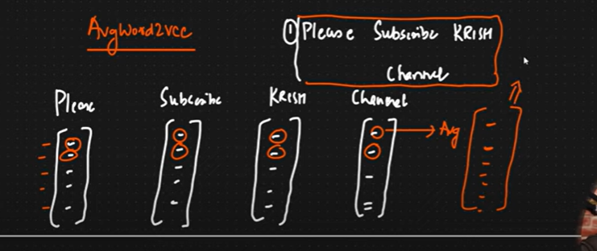

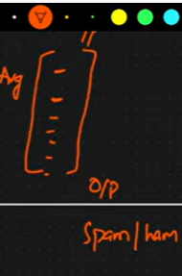

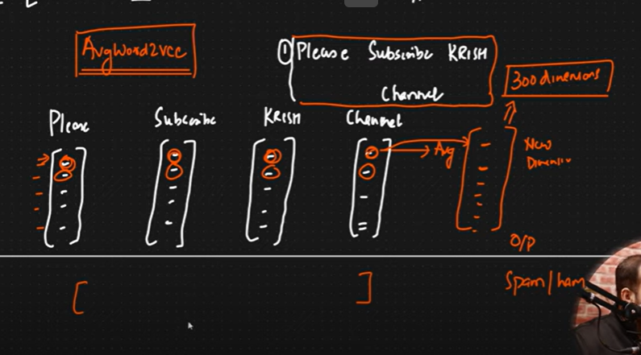

Download word2vec

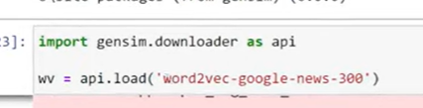

But I want to create from scratch

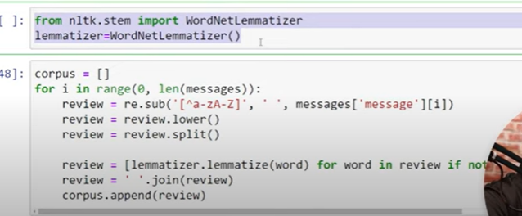

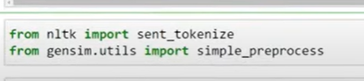

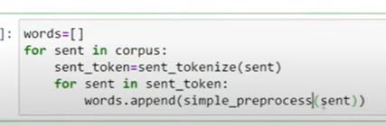

Simple preprocess: convert

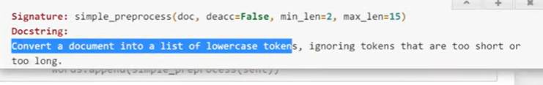

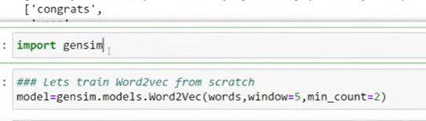

Vector size= 100

By_default=100

To get the vocabulary

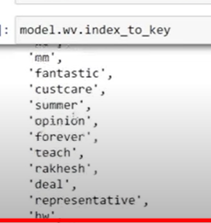

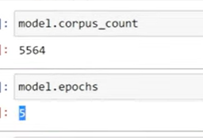

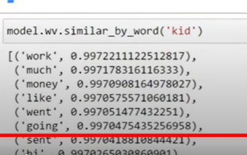

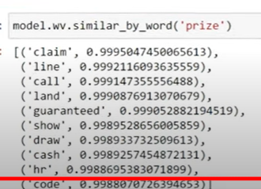

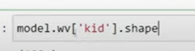

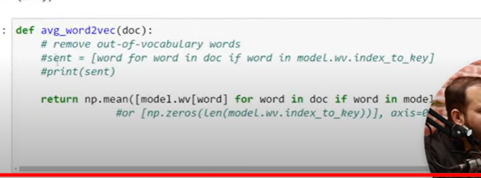

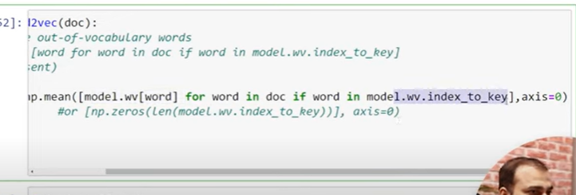

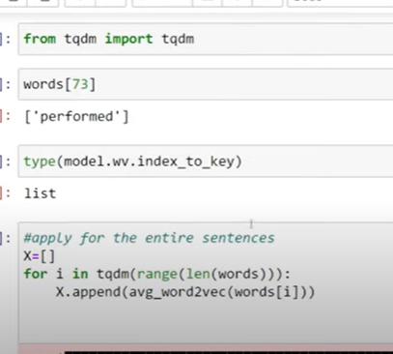

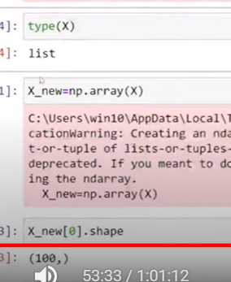

First sentence

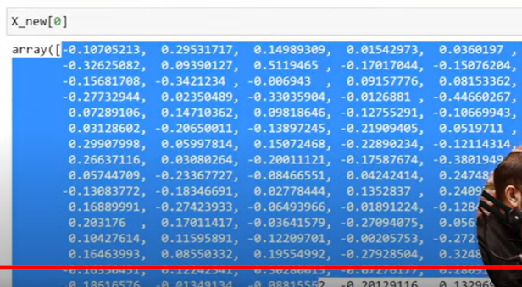

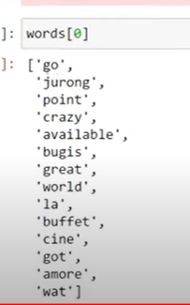

1st sentence has 100 vectors

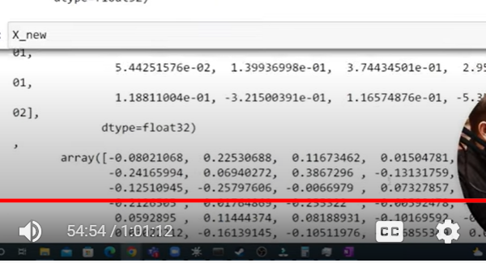

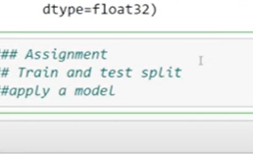

[NLP-Live/Day 5- NLP Word2vec And AvgWord2vec.ipynb at main · krishnaik06/NLP-Live · GitHub](https://github.com/krishnaik06/NLP-Live/blob/main/Day%205-%20NLP%20Word2vec%20And%20AvgWord2vec.ipynb)

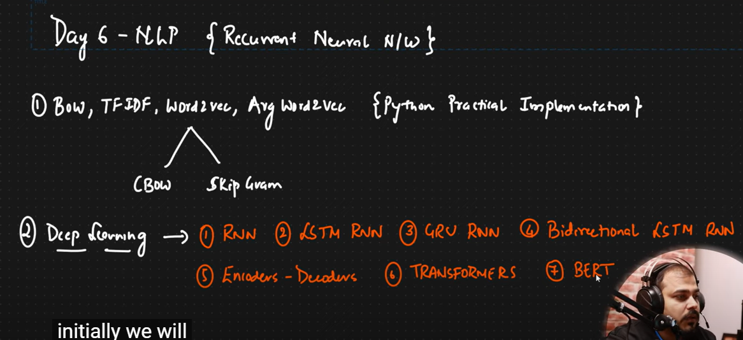

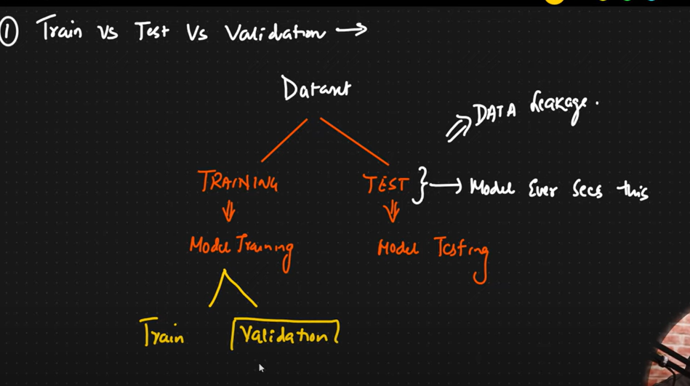

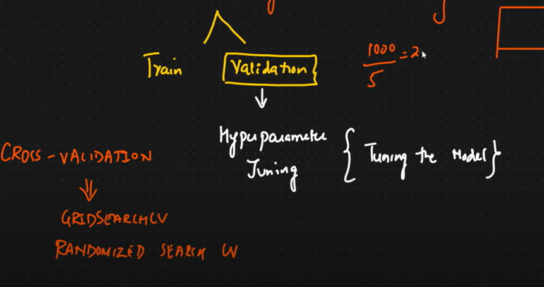

If I am performing cross validation of 5

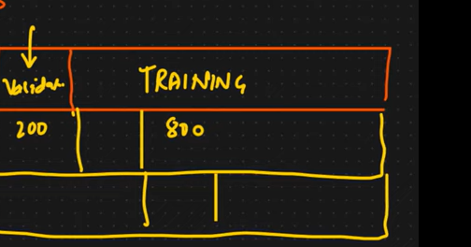

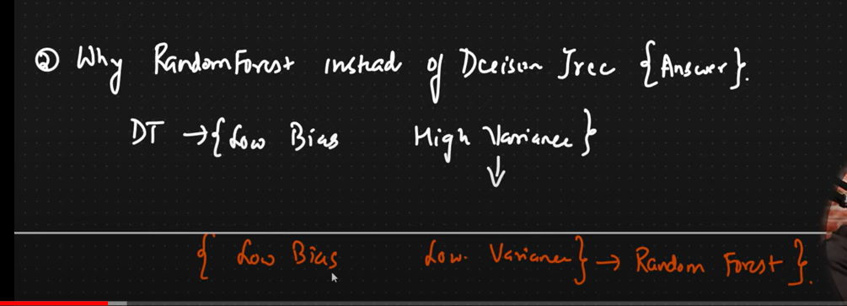

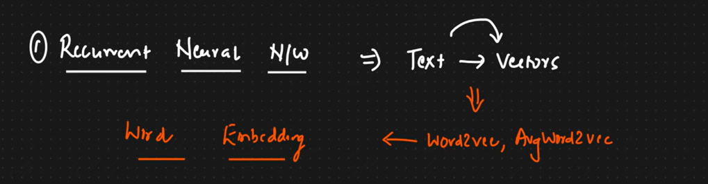



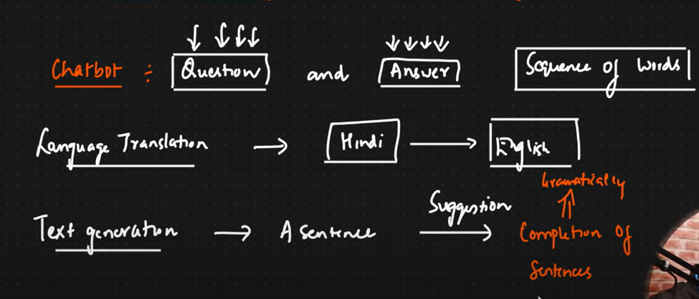

For all these we cant depend on machine learning

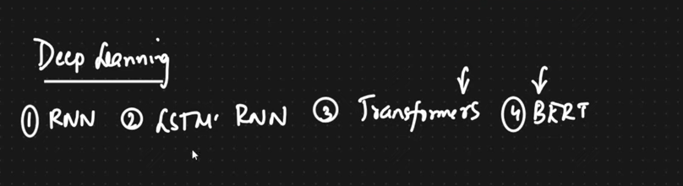

Word2vec:

Tech in deep learning – which we can train model which converts word into vector to capture symantic meaning

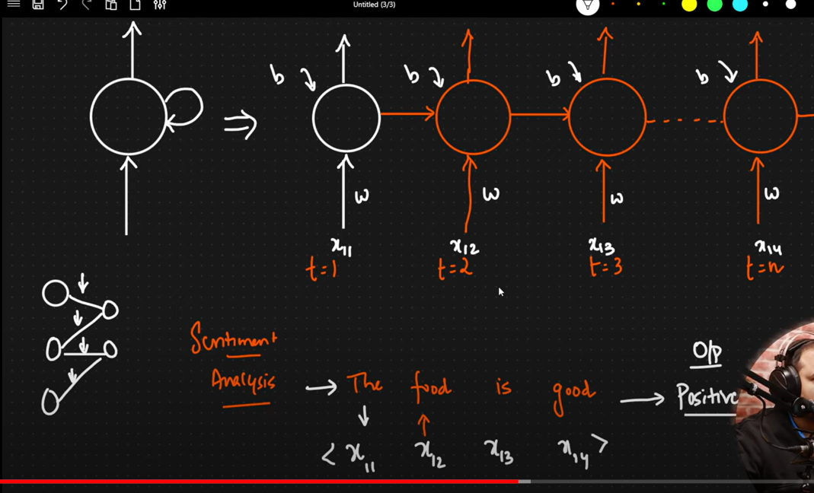

Types of RNN

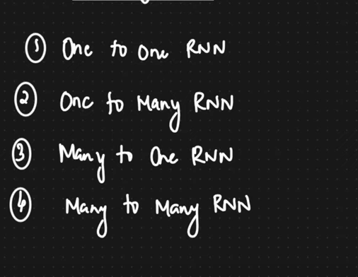

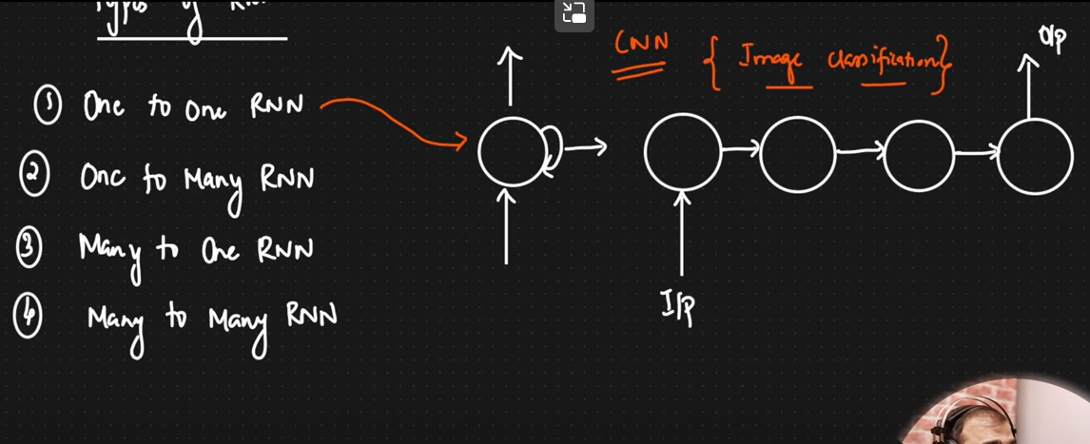

One to many

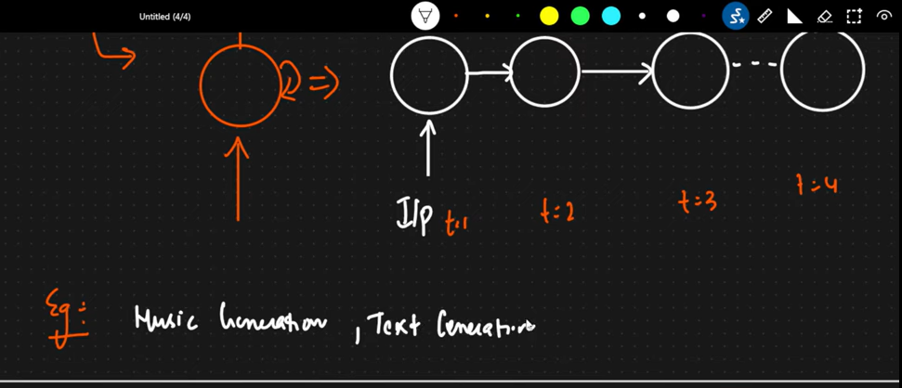

Google search suggestion

Movie recommendation

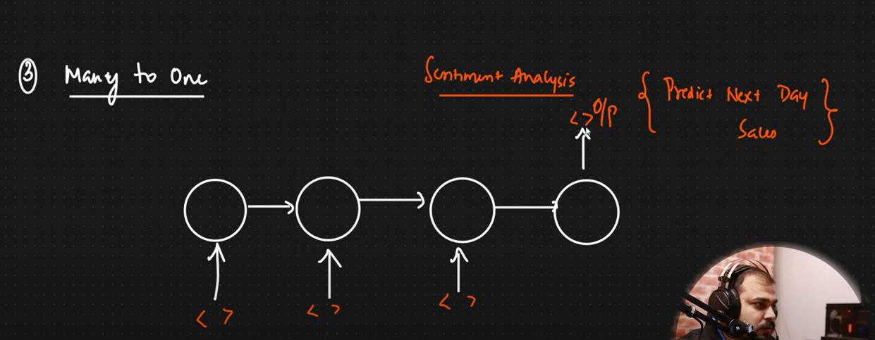

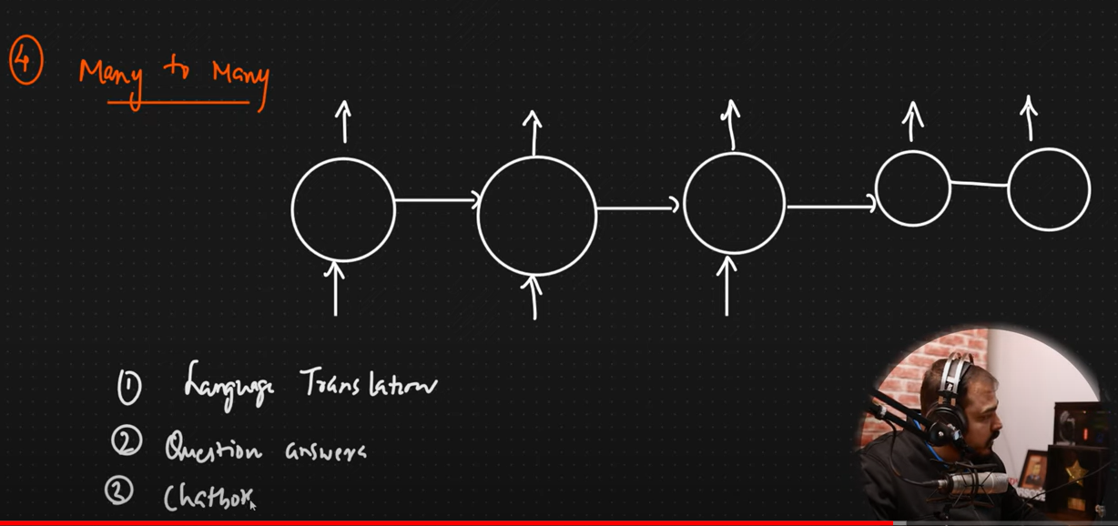

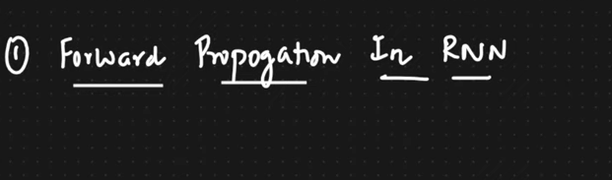

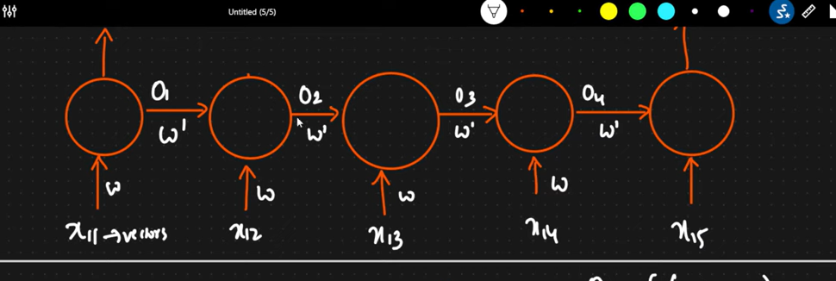

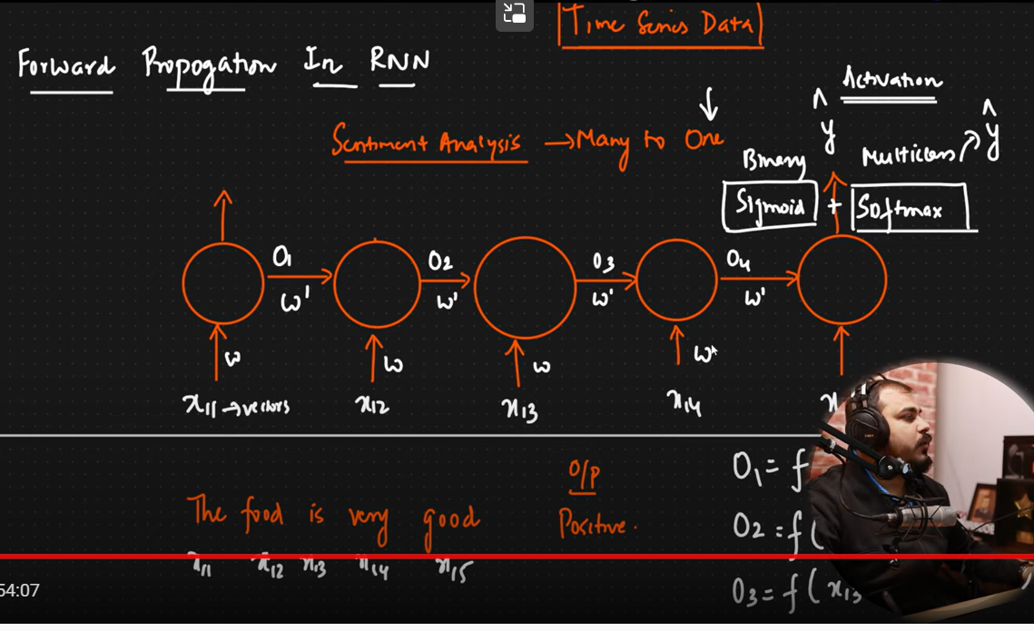

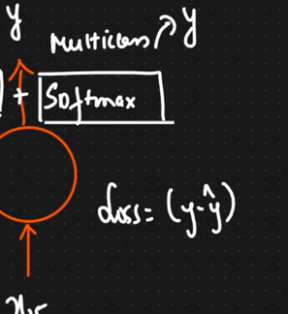

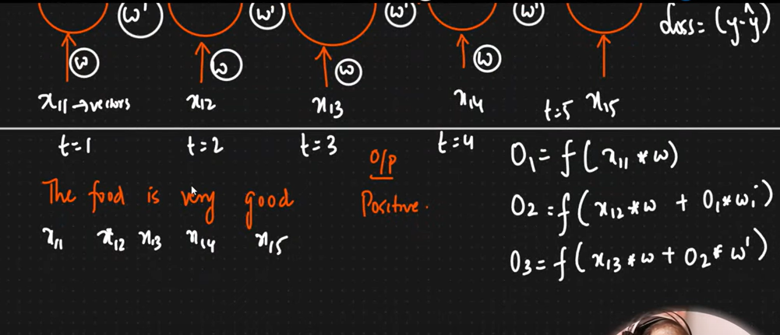

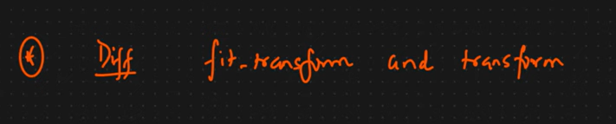

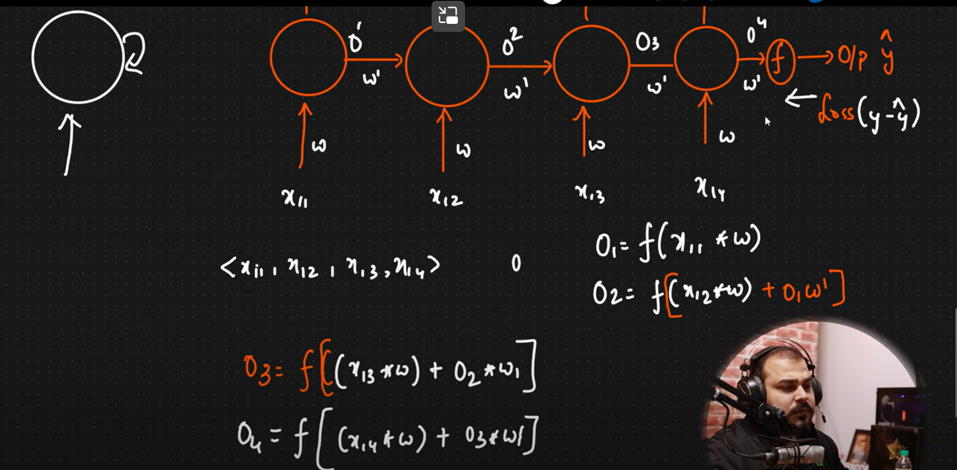

**BackPropogration In Recurrent Neural Network And NLP Application|Krish Naik**

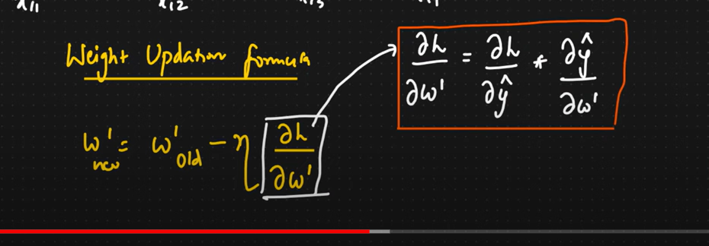

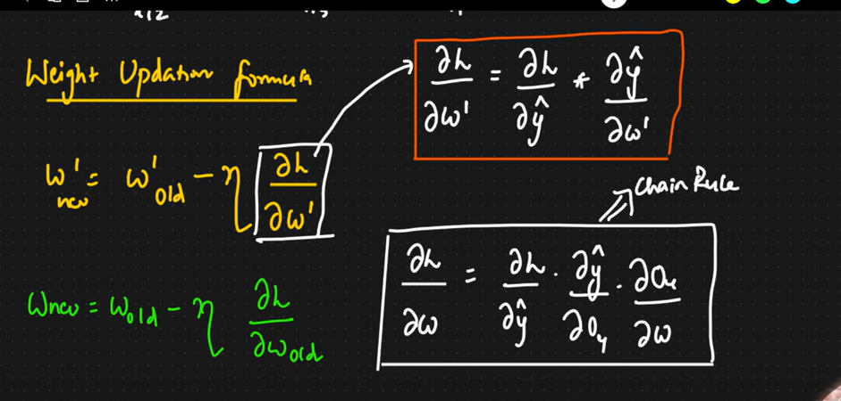

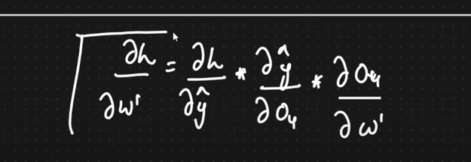

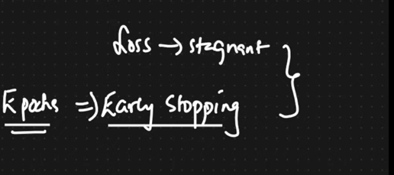

If rnn is completely depth: what kind of problems can be faced : vanishing gradient descent

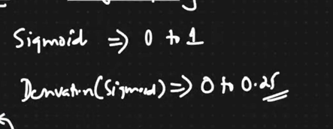

Weight updating will be very small

To solve this

LSTM

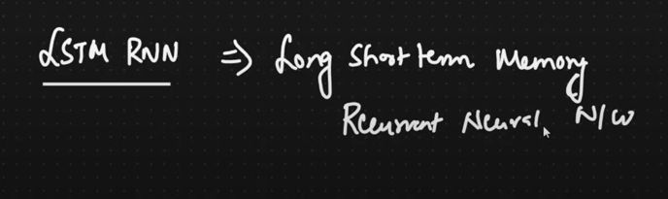

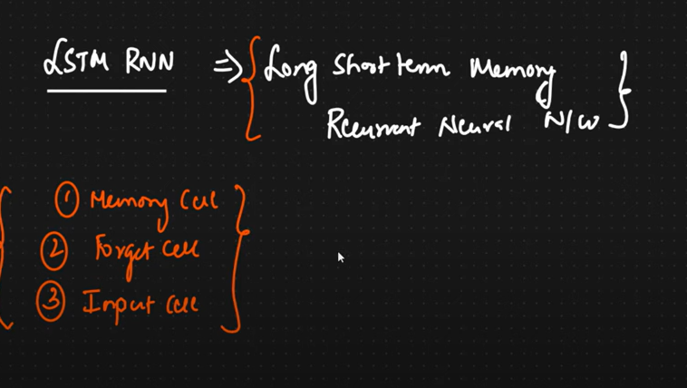

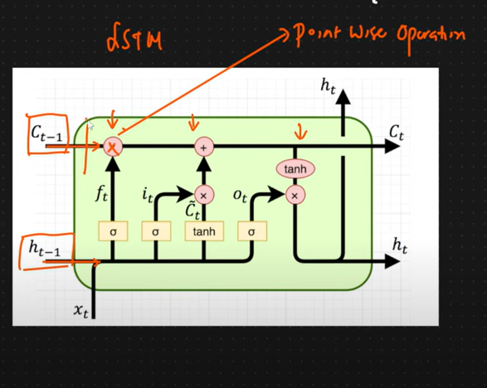

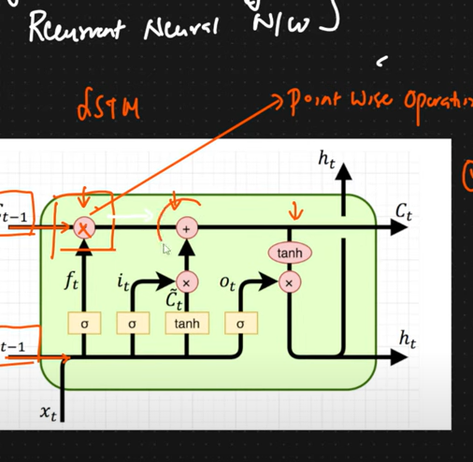

At memory cell: we are forgetting some info, adding some info

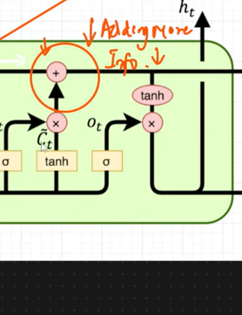

Why LSTM instead of RNN?

1. Vanishing gradient or dead neuron problem
2. Context info
3. 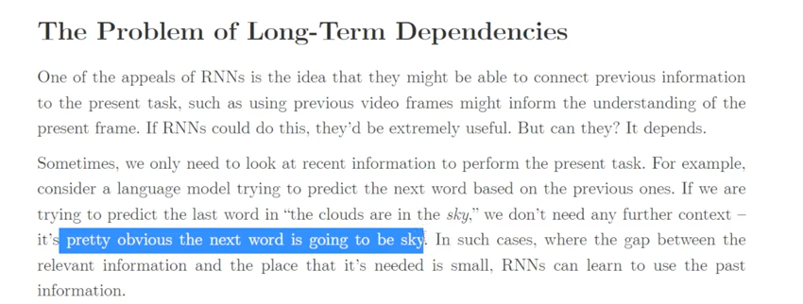
4. If the gap is small( out put depends on previous word--- rnn enough)

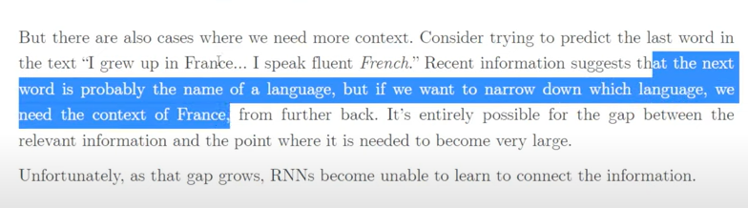



**Word Embedding Layer And LSTM Practical Implementation In NLP Application|Krish Naik**

In lstm : word embedding layer which converts words into vectors

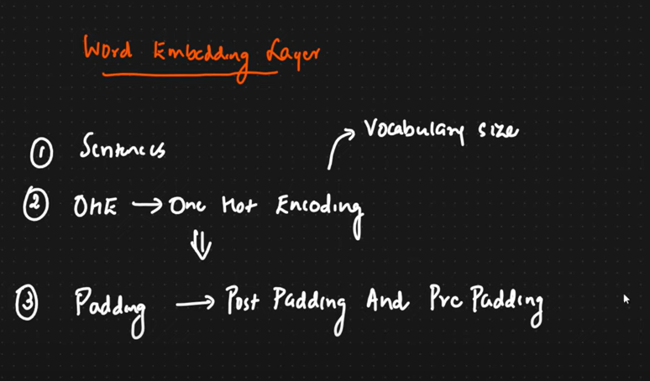

Noe one hot encoded values will be converted to vectors

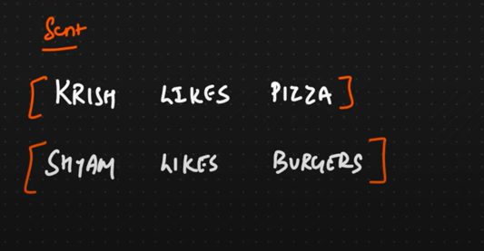

Total number of unique wors(vocabulary )=1000

One hot encoding for krish

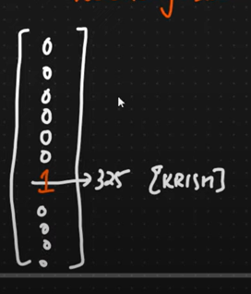

I need to take all words and create embedding layer and convert them to vector . this will be done by embedding layer in deep learning

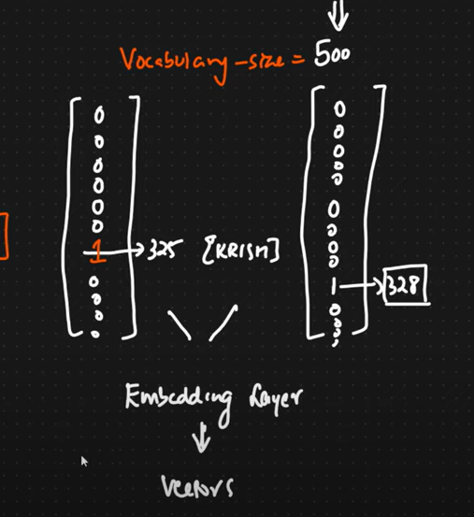

This stem is text pre-processing

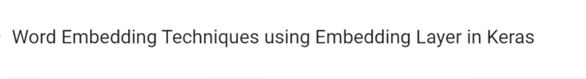

[Day 9-Word Embedding Layer And LSTM Practical Implementation In NLP Application|Krish Naik - YouTube](https://www.youtube.com/watch?v=FWQ2SvE-nbM&list=PLZoTAELRMXVNNrHSKv36Lr3_156yCo6Nn&index=11)

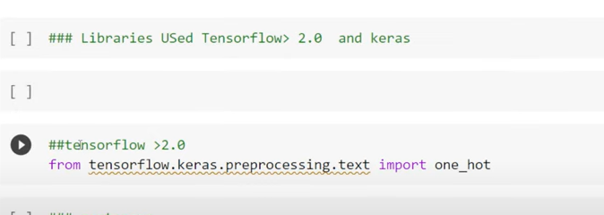

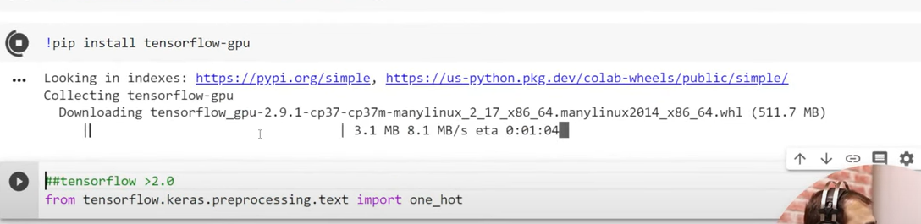

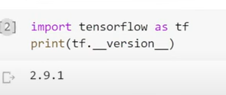

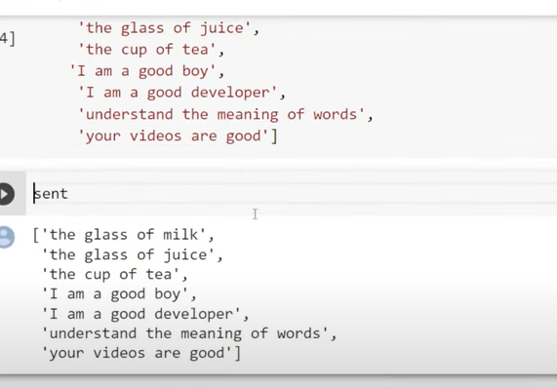

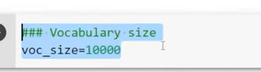

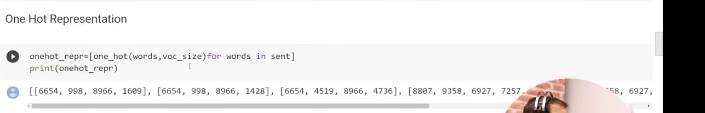

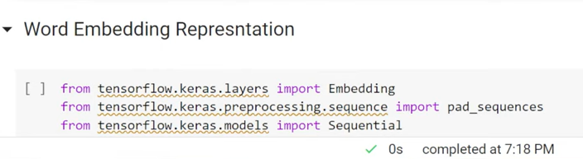

Each sentence has different length

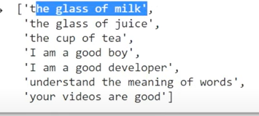

Different sentence has different size

To train neural network my sentence size should be fixed

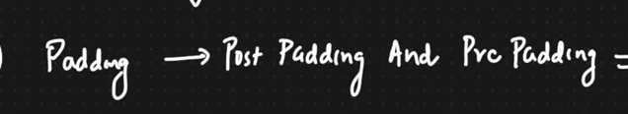

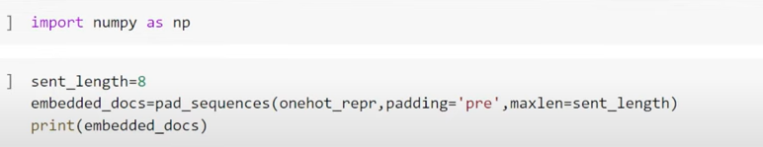

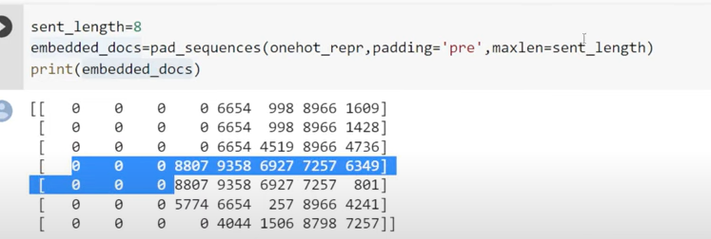

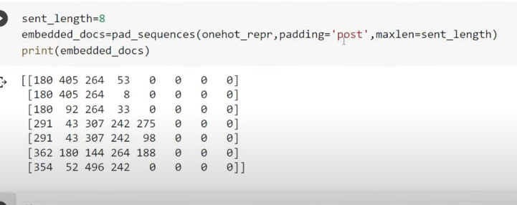

Now convert each value into vector

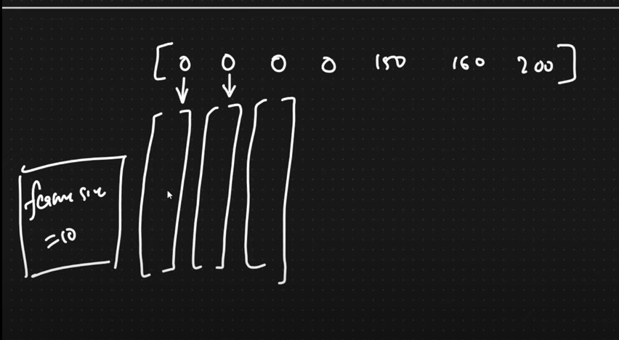

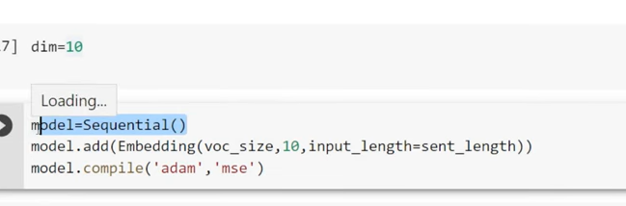

Embedding layer: work like word2vec

Voc­_size

10- feature size

Max _length : 8(no of words in each sentence)

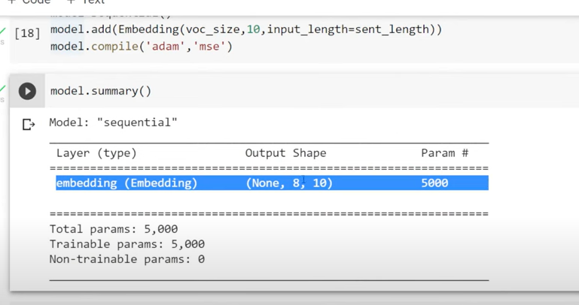

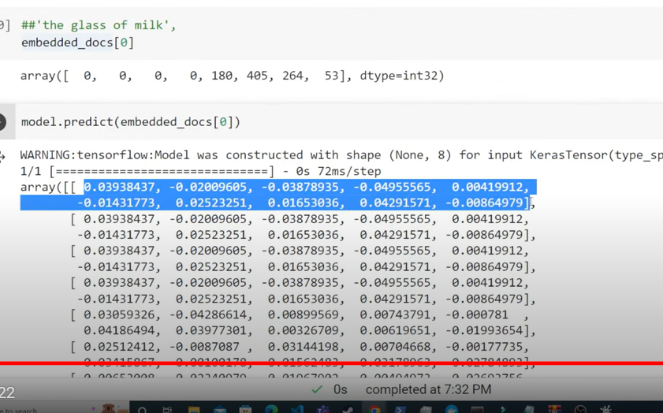

0 th word represented by 10 dimensions

For all words

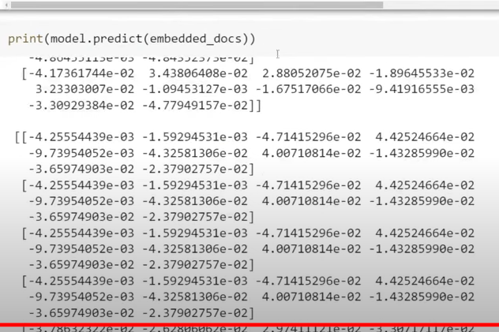

Now create LSTM

**- LSTM Practical Implementation In NLP Application|Krish Naik**

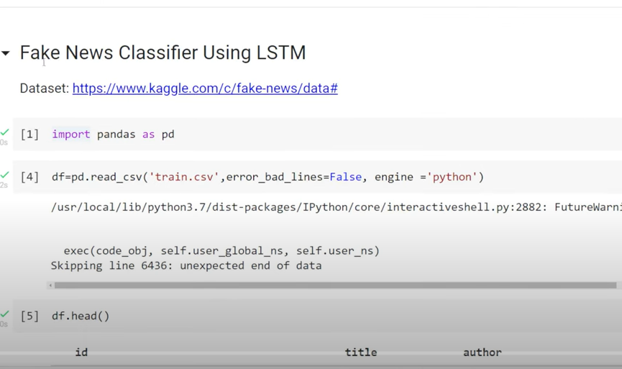

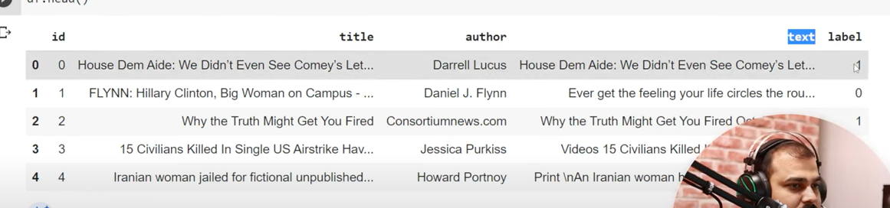

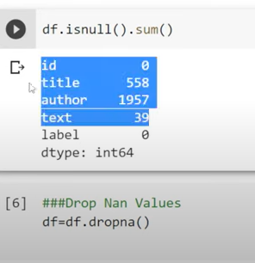

Since it is text data we cant replace \

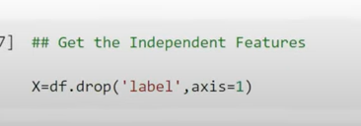

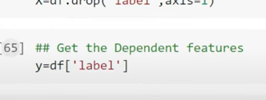

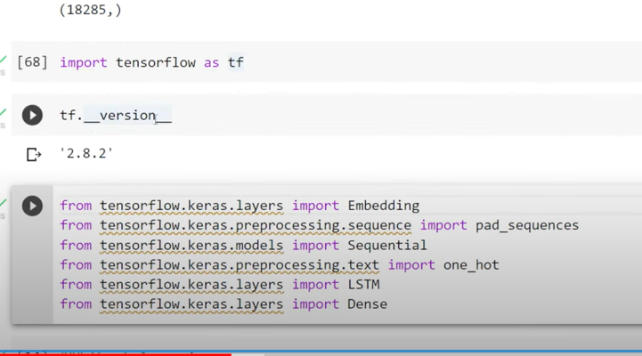

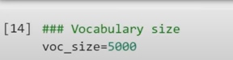

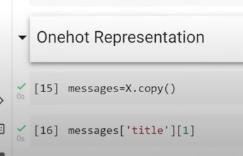

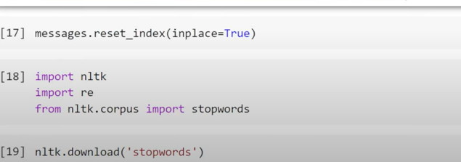

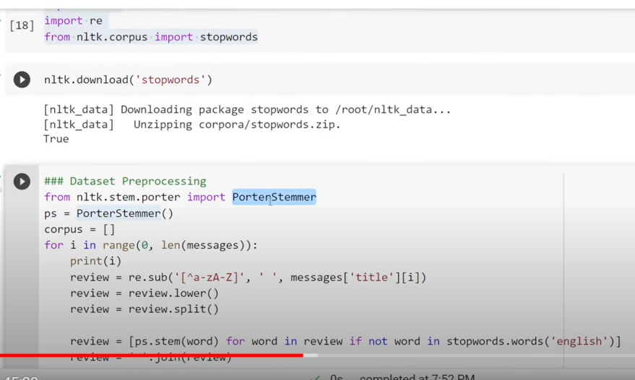

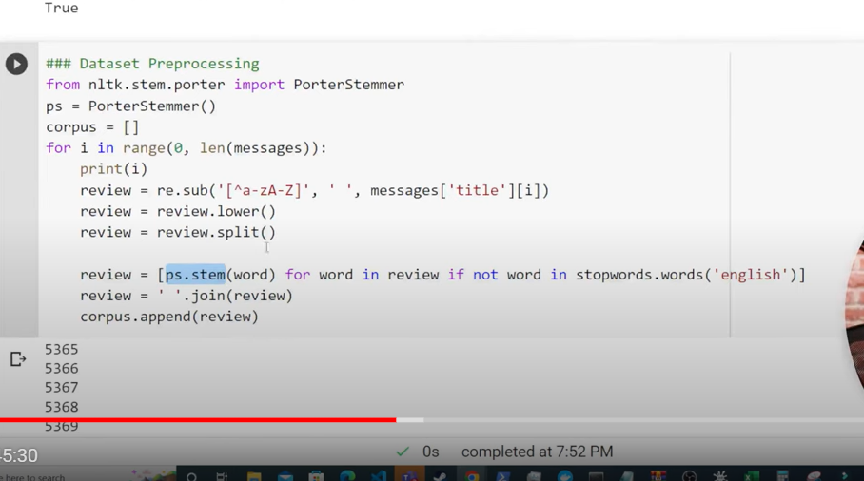

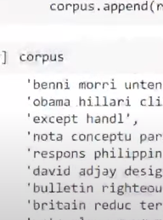

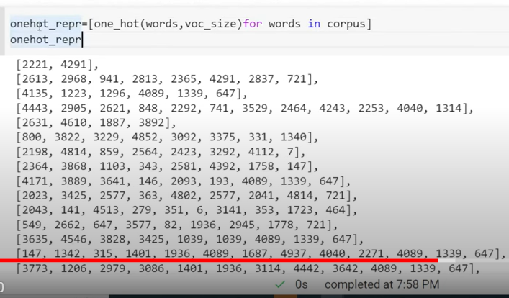

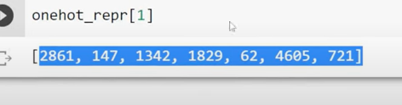

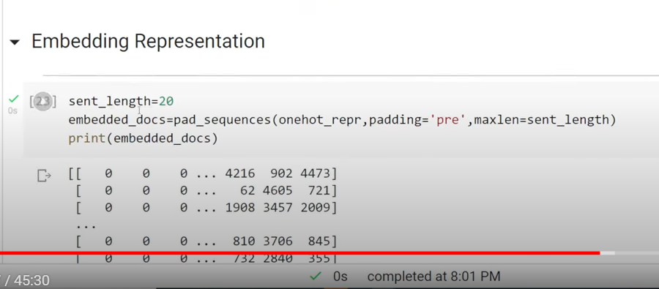

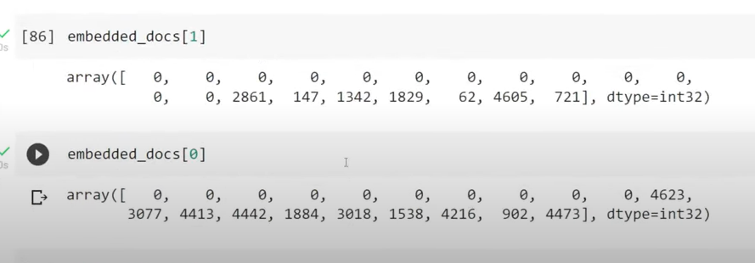

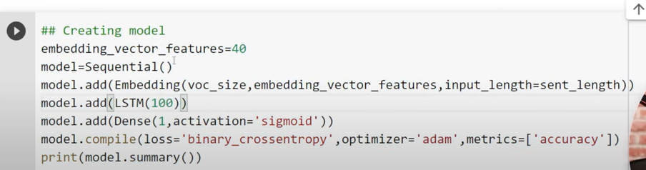

Embedding_vector_feature=40 means each word converted to 40 featured vector

Lstm(100) = 100 neurons

Sigmoid : since output is binary

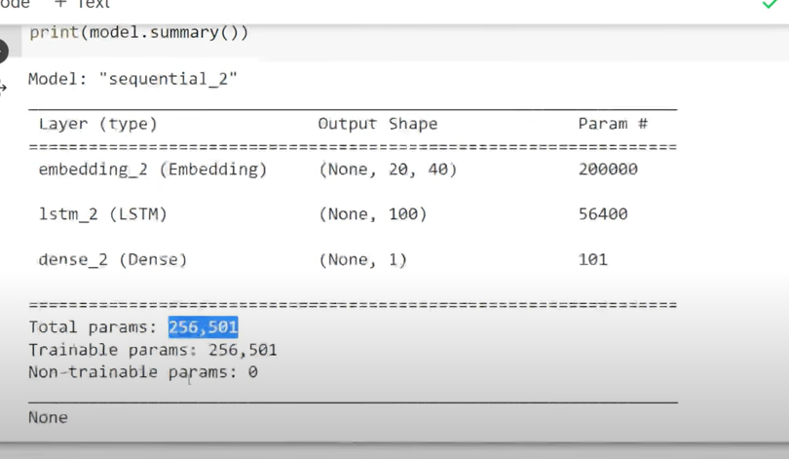

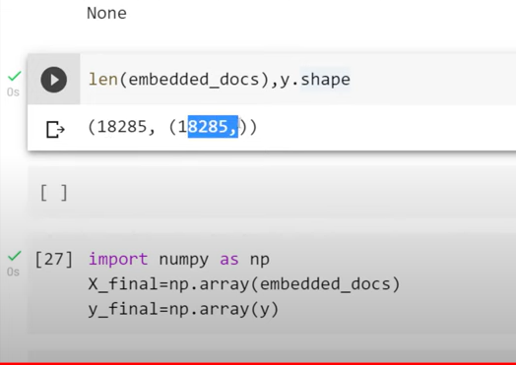

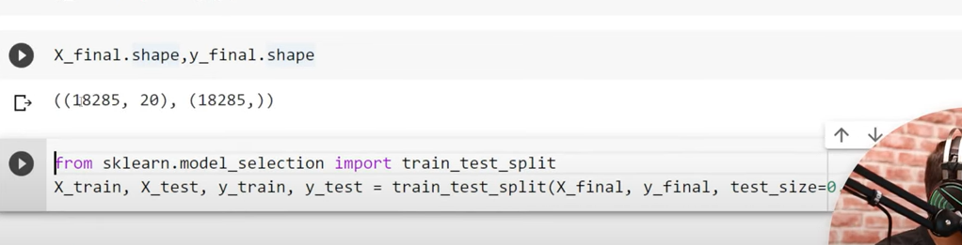

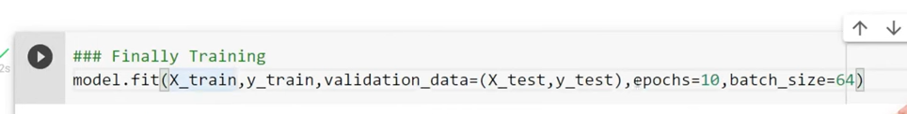

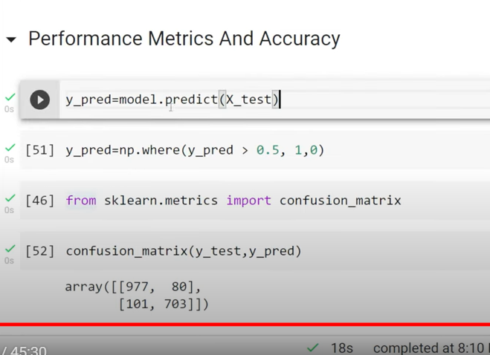

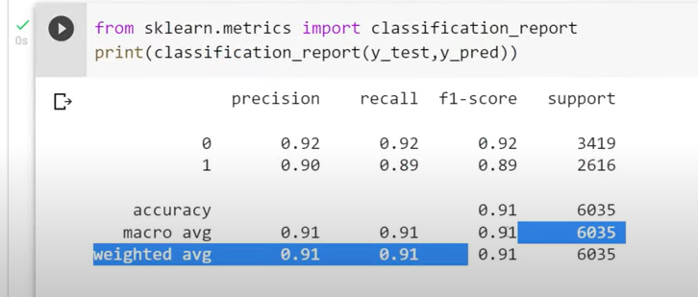

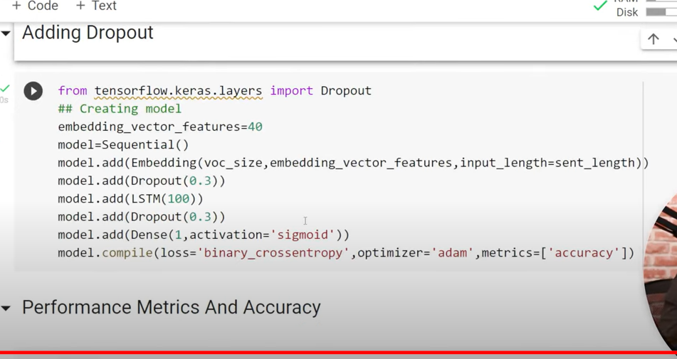

After embeding layer and lstm layer drop outs were added

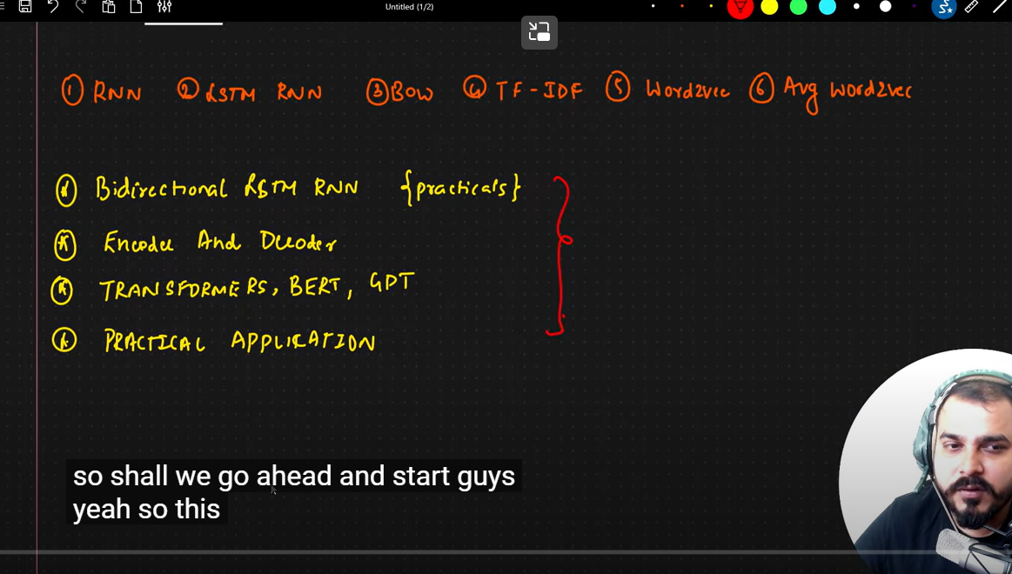

**-Bidirectional LSTM Intuition And Implementation Deep Learning|Krish Naik**

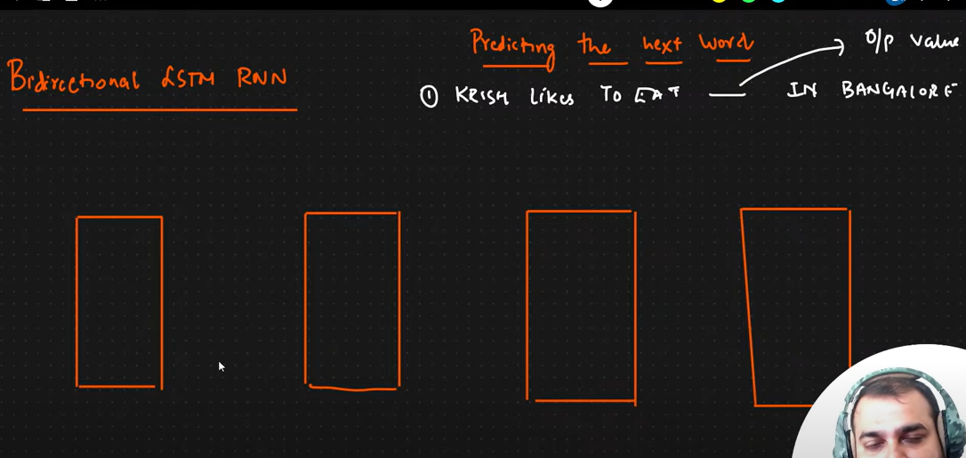

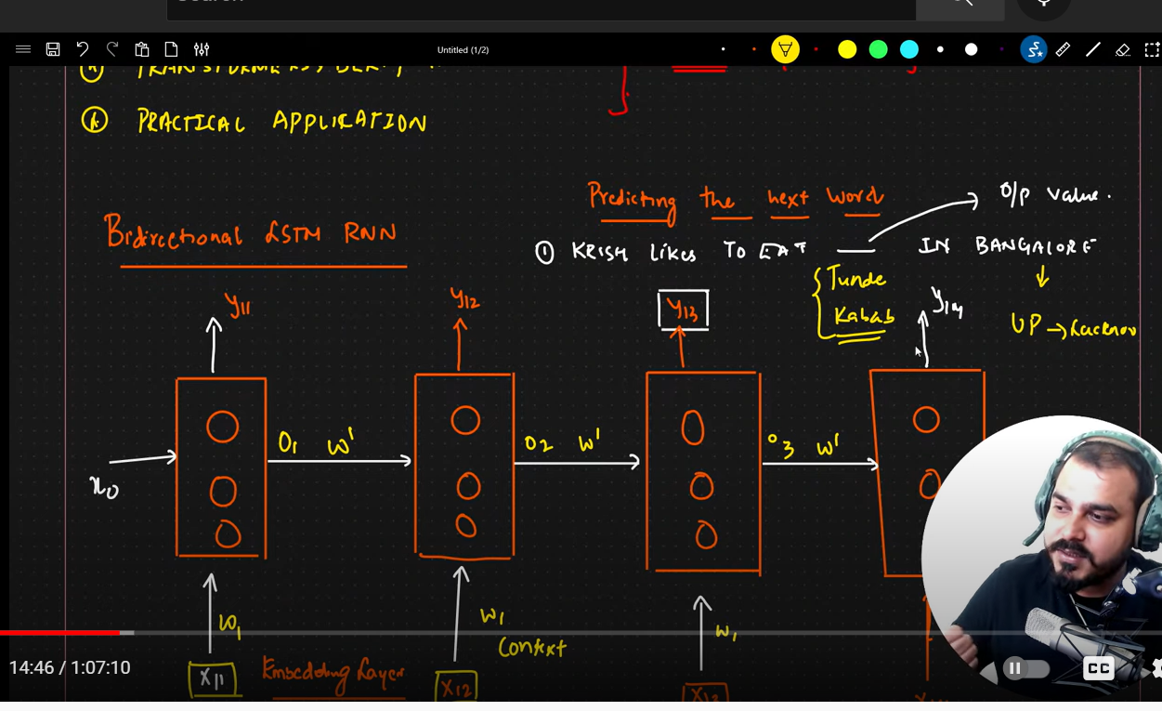

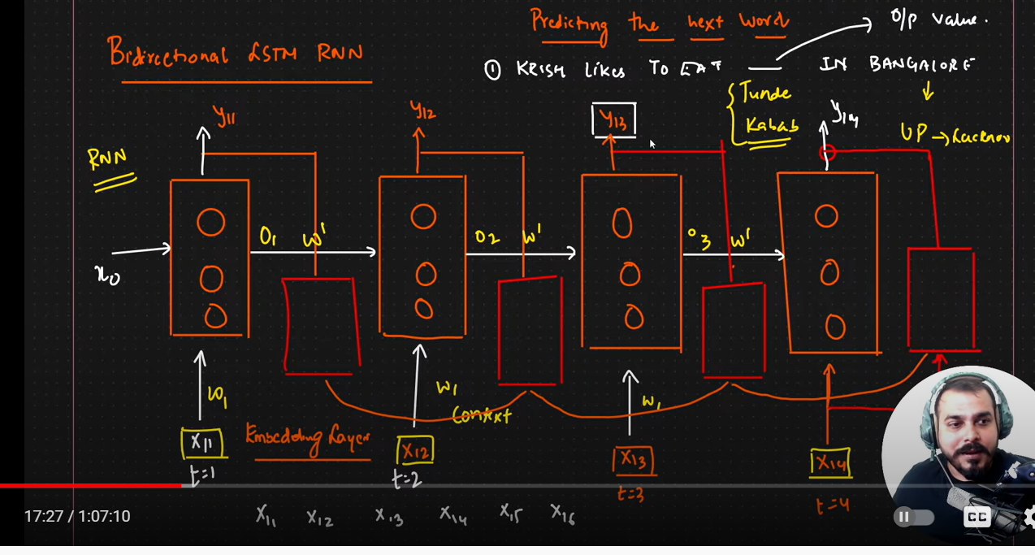

We are also sending text to reverse order as well

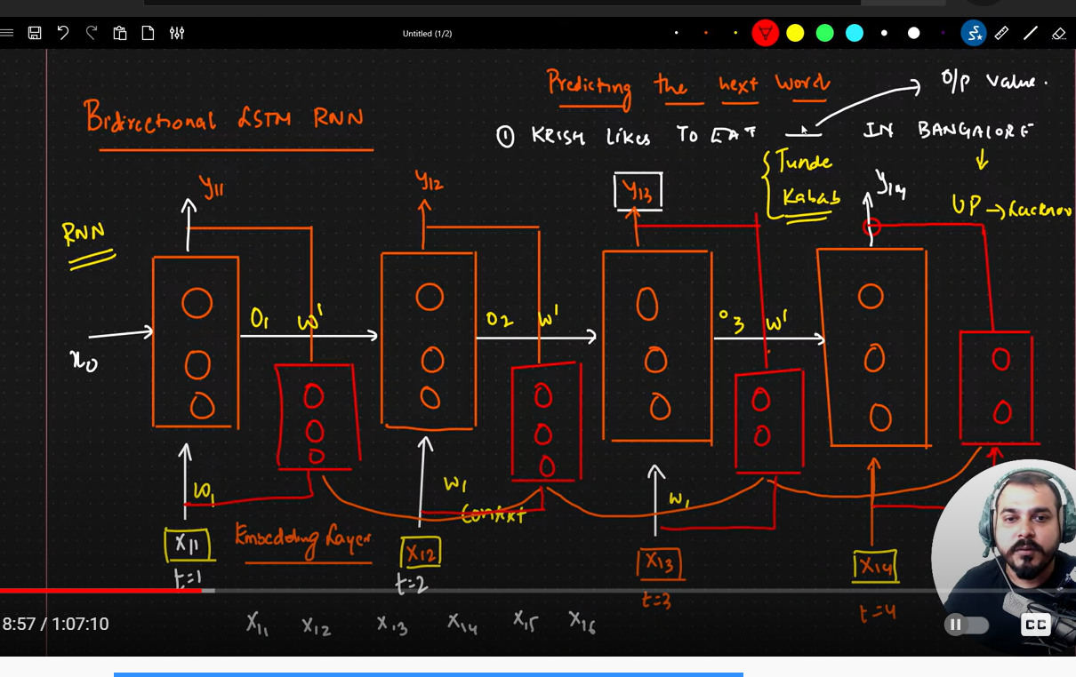

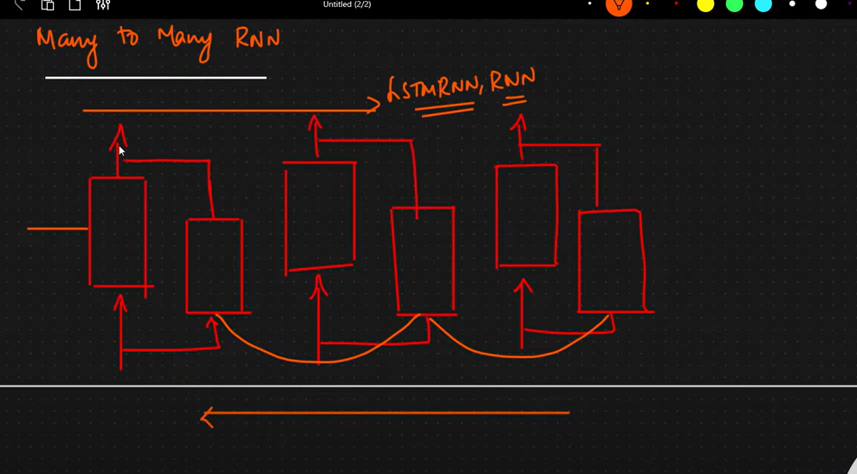

For each out has contect of words from the beginning and from the ending

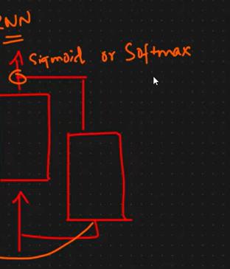

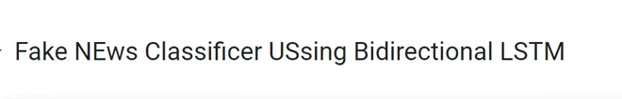

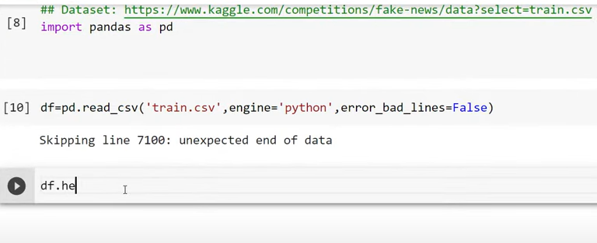

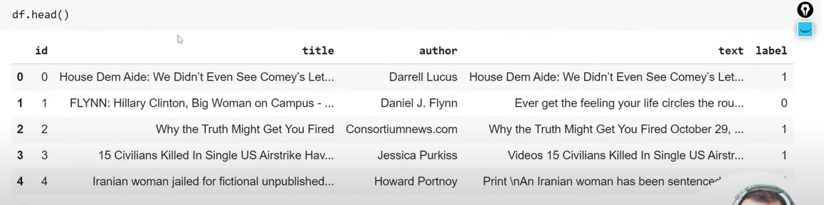

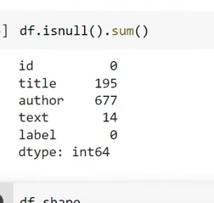

Remove null values

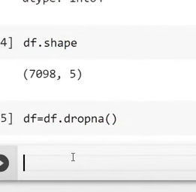

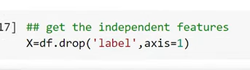

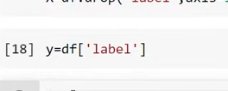

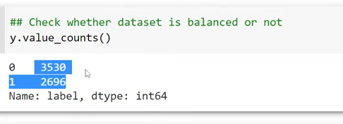

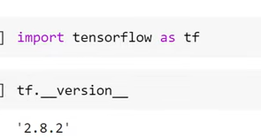

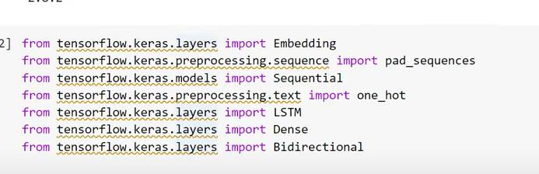

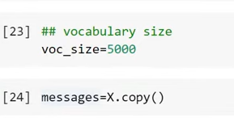

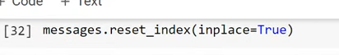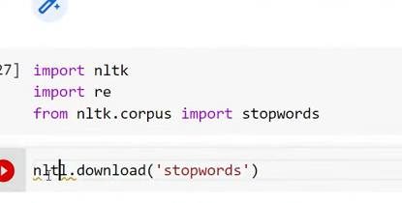

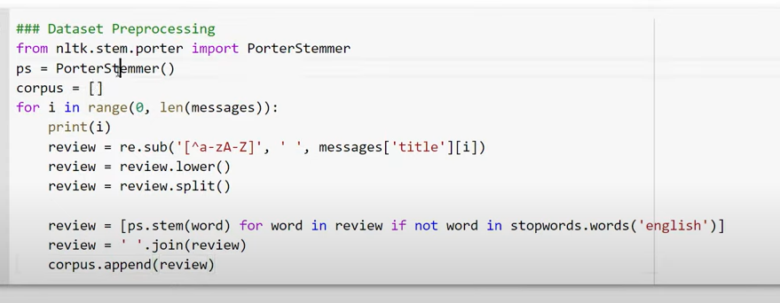

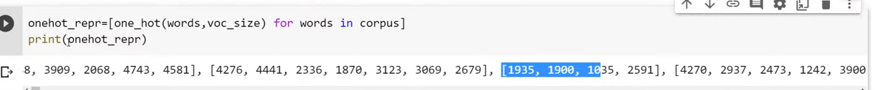

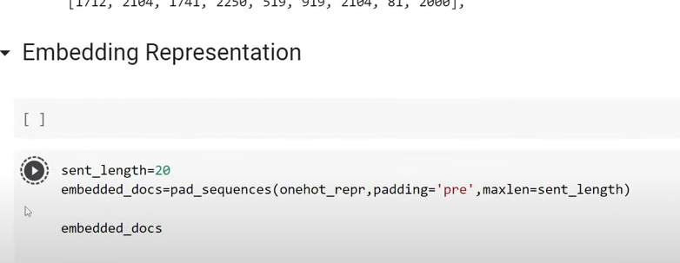

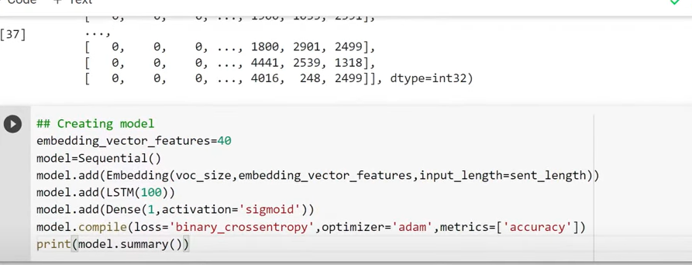

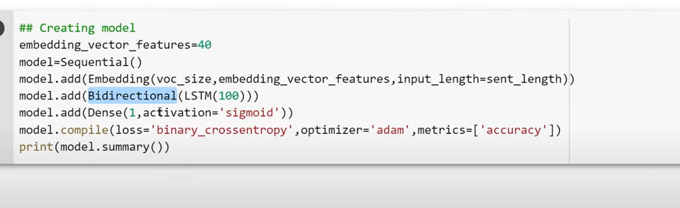

100 neurons forward

100 neurons backward

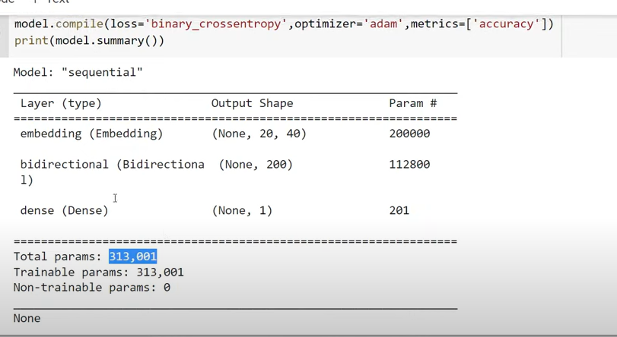

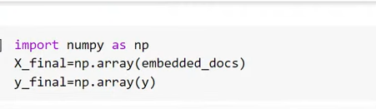

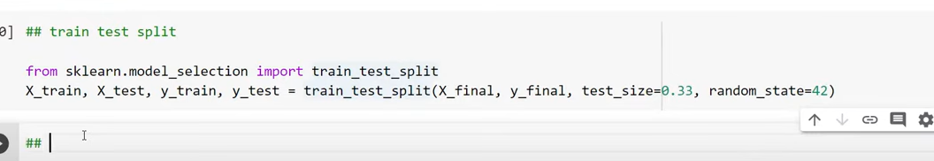

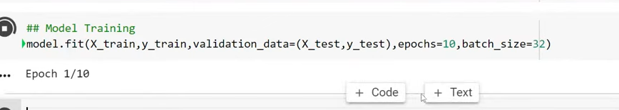

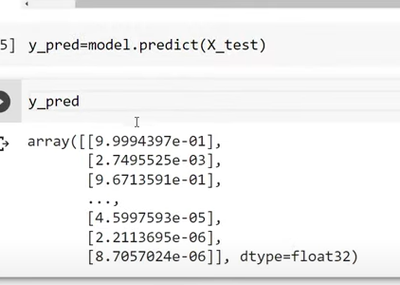

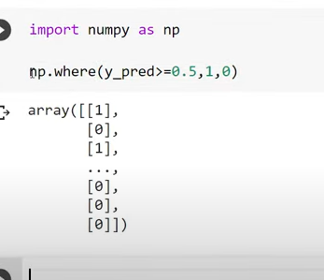

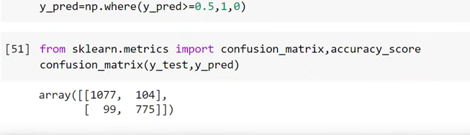

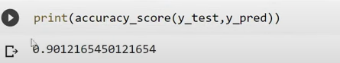

**Sequence To Sequence Learning With Neural Networks| Encoder And Decoder In-depth Intuition**

Example: sequence to sequence

Model takes sequence of info gives sequence of info

Language translation

Image captioning

Mesg – automated reply(chatbox)

2 main components

1. Encoders
2. Decoders

Language translation (English- French)

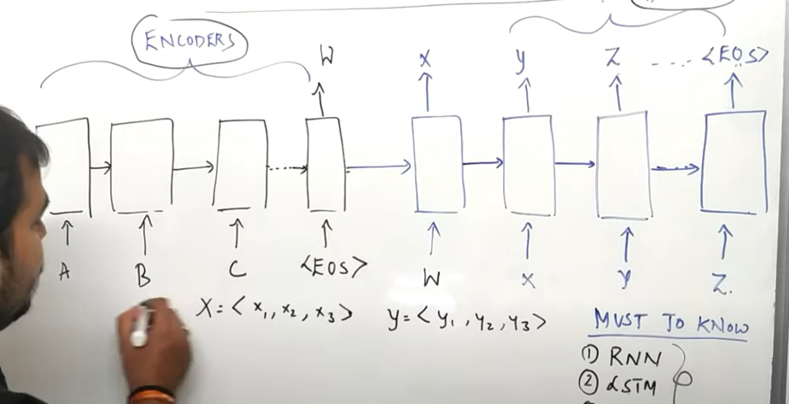

We can take either rnn, lstm or gru

For encoder output will not be there

The output will be presented at last timestamp

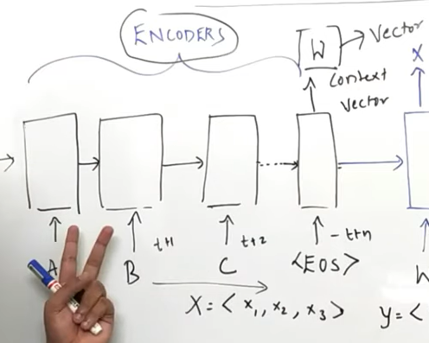

In language processing we generally pass vectors

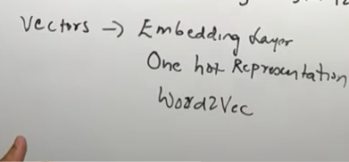

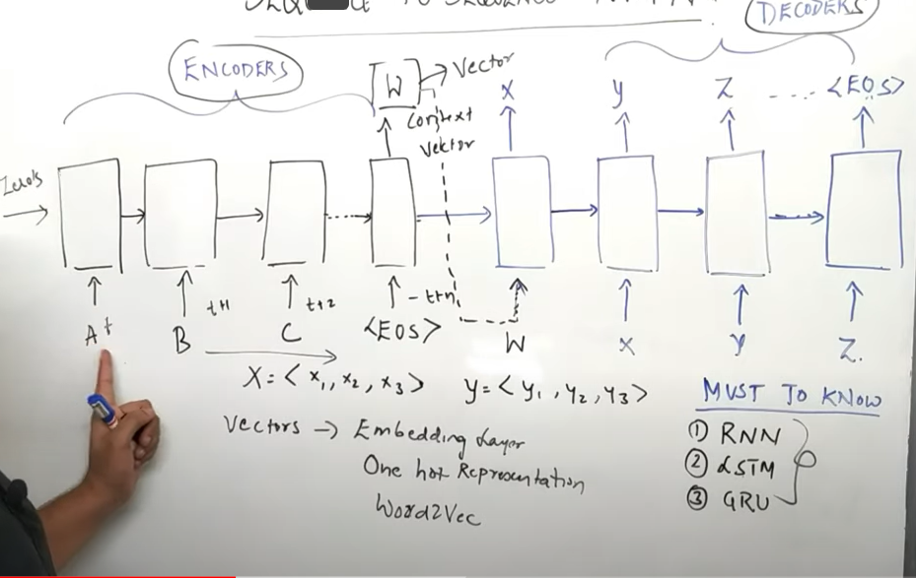

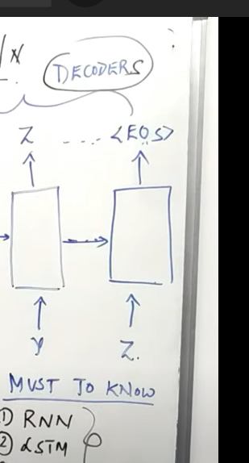

Finally we get EOS(end of the string)

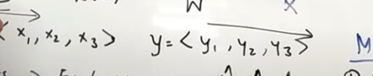

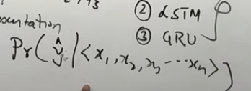



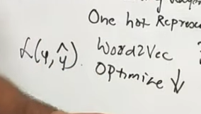

In back propagation weights get updated in adam optimizer

One problem :

Long sentence accuracy is not good

Blue score(translation accuracy)

To solve this attention model

Instead of LSTM they use bidirectional LSTM

**Encoder And Decoder- Neural Machine Learning Language Translation Tutorial With Keras- Deep Learning**

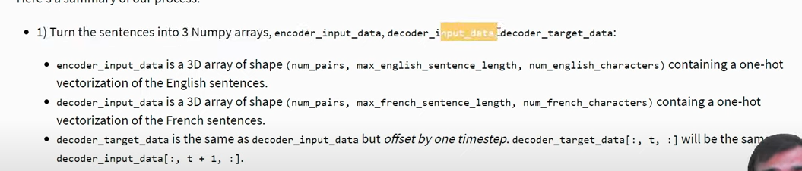



Number of pairs: number of sentences

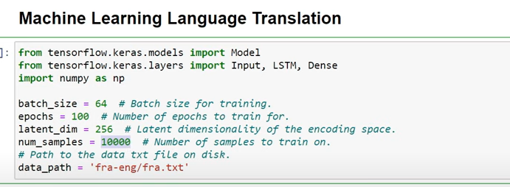

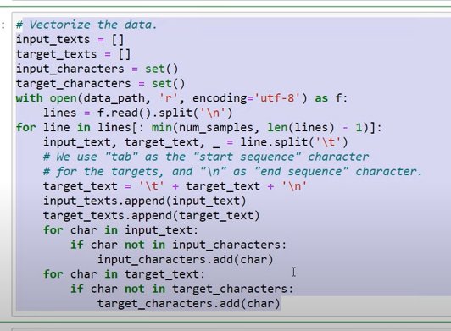

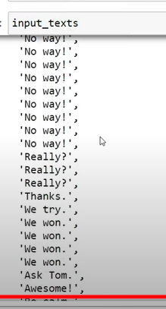

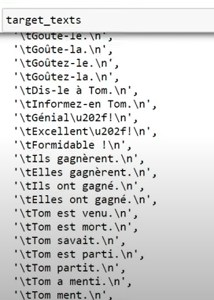

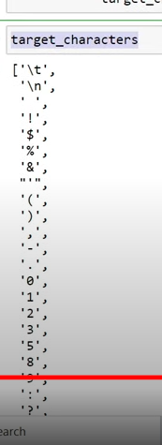

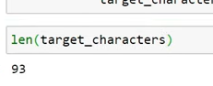

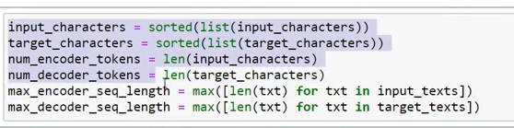

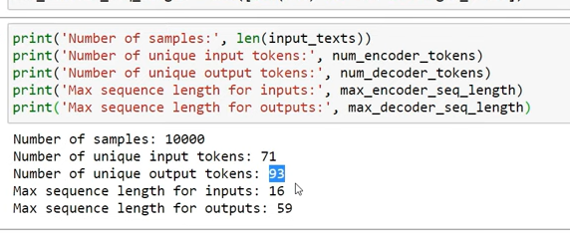

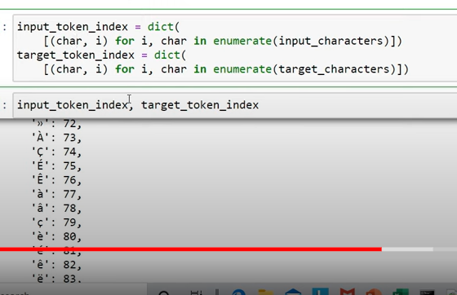

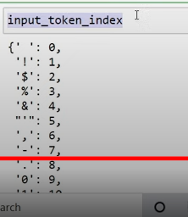

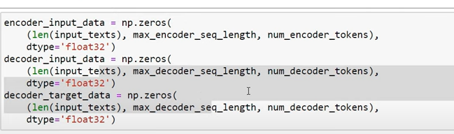

[Encoder And Decoder- Neural Machine Learning Language Translation Tutorial With Keras- Deep Learning - YouTube](https://www.youtube.com/watch?v=f-JCCOHwx1c&t=926s)

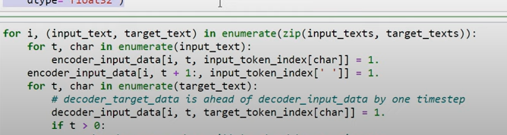

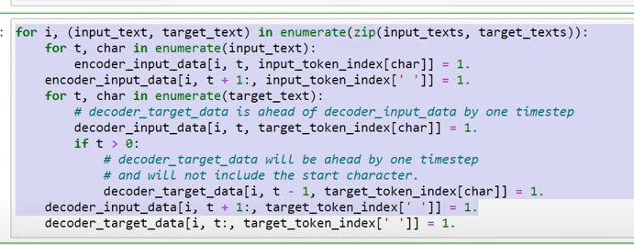

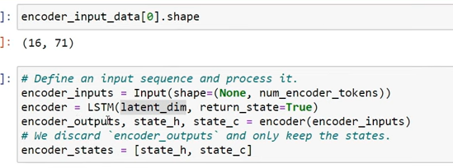

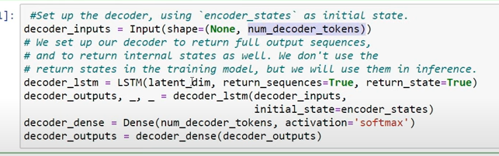

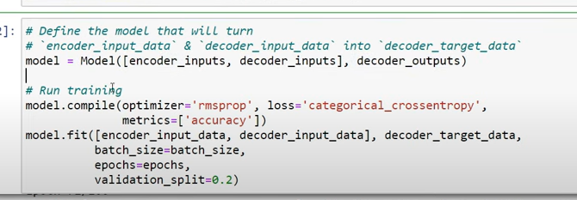

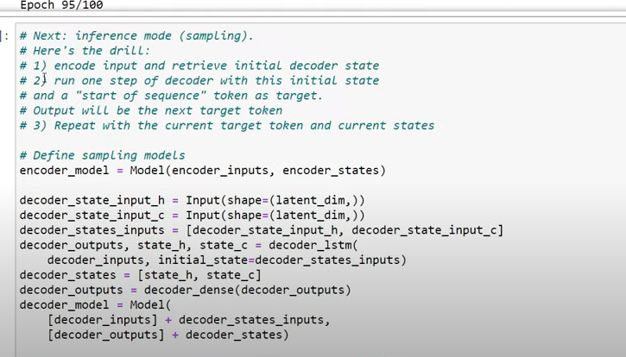

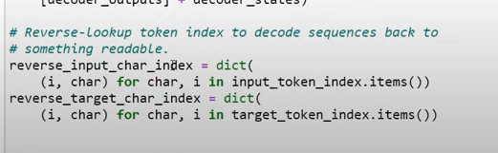

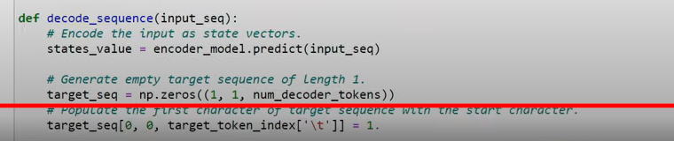

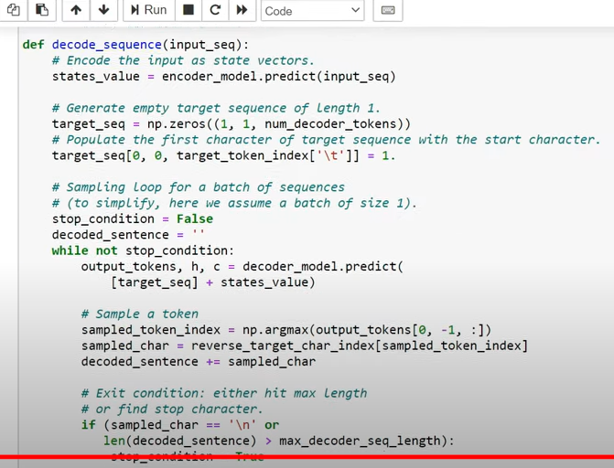

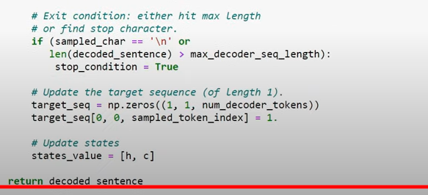

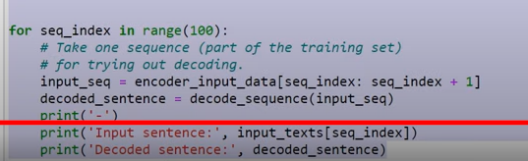

[A ten-minute introduction to sequence-to-sequence learning in Keras](https://blog.keras.io/a-ten-minute-introduction-to-sequence-to-sequence-learning-in-keras.html)

**Problems With Encoders And Decoders- Indepth Intuition**

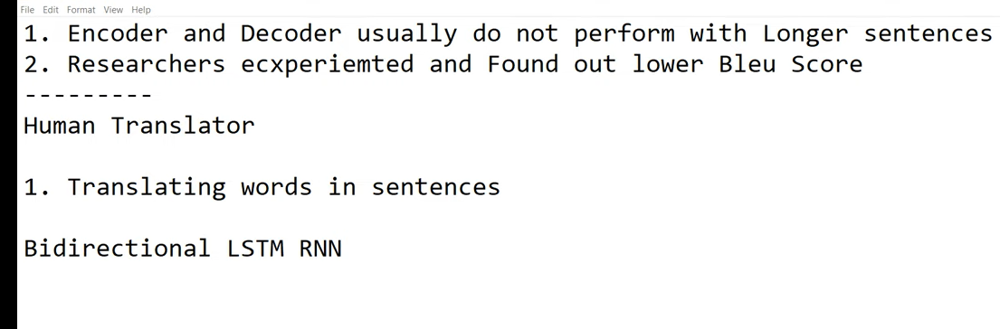

Taking window size

**eencoder Decoder,Attention Models, Transformers, Bert Part 1**

**Attention model or layers**

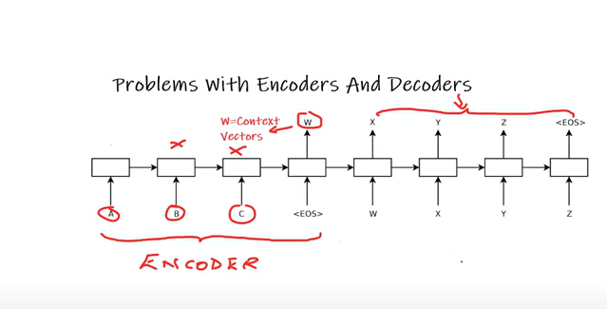

In encoder and decoder: both are uni directional

But in attention model: in encoder instead of using lstm RNN use bidirectional LSTM RNN

Use of bidirectional LSTM RNN:

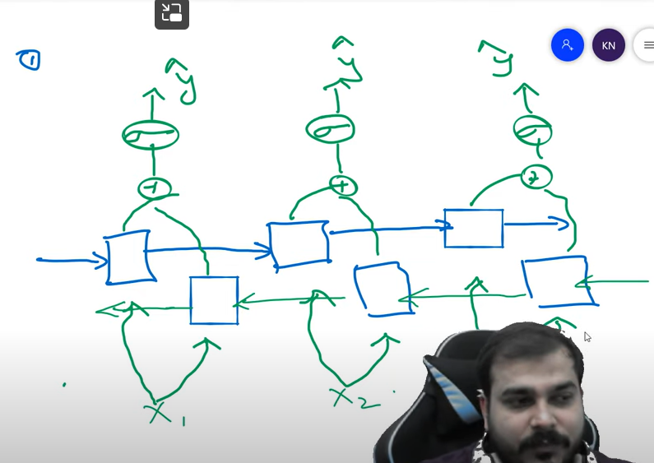

Use of bidirectional RNN  
in case of longer sentence I will be able to get information of the future words

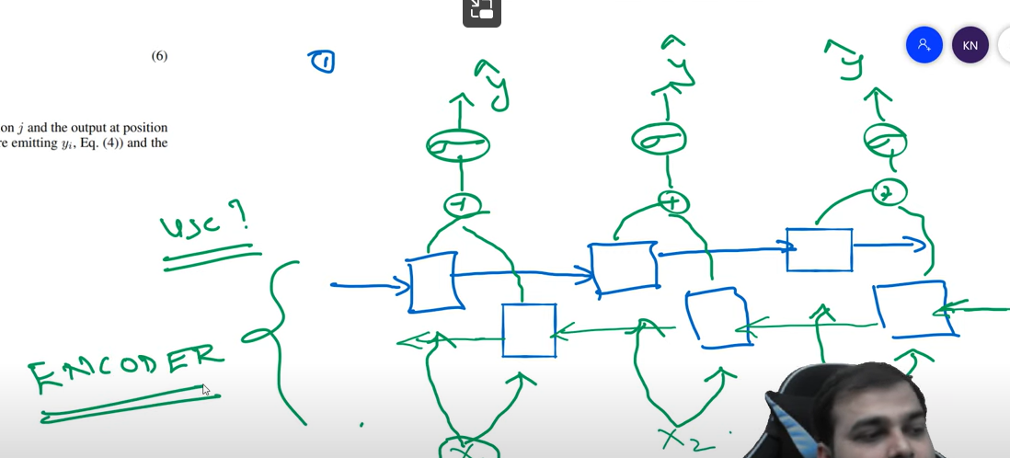

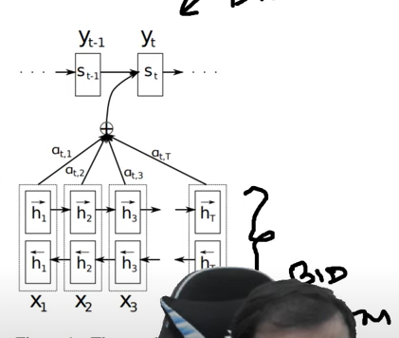

The other change in encoder is

BUT in decoder will be having simple LSTM only

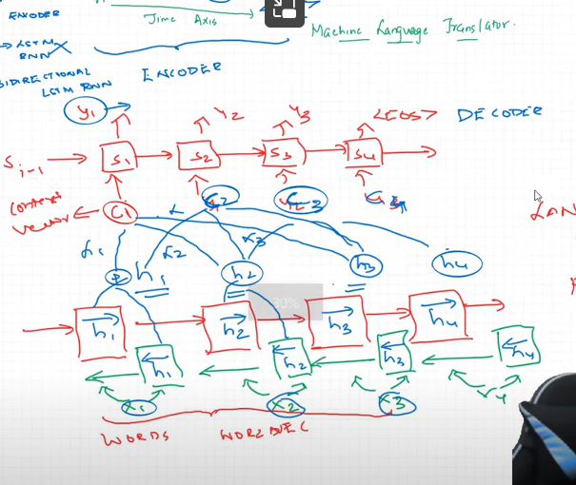

Window size= 3

Alpha ti , alphat2 --- weights

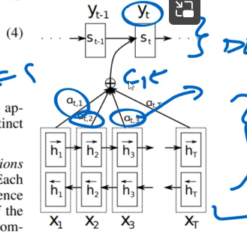

At a time we are giving attention to some words :

3 words

By what mechanism alpha values getting initialized:

T(x): any size

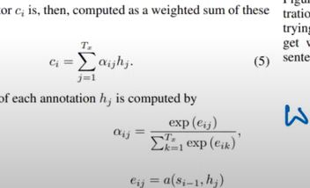

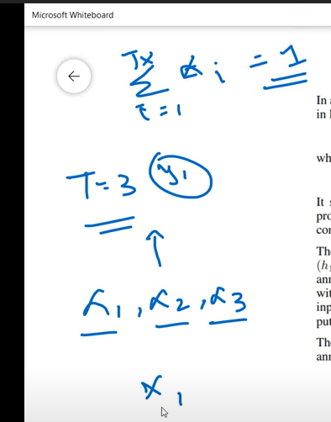

All 3 alpha values must be equal to 1

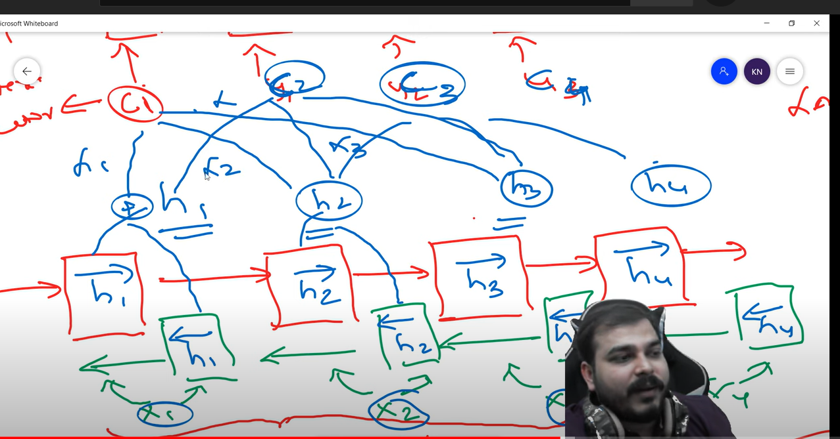

C1=H1*alpha1+h2*apla2+h3*alpha3

This is the property of feed forward network

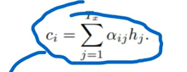

I can change alpha value in back propagation

Softmax function

Helps us to make summation of alpha value as 1

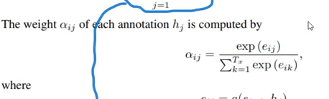

**Transformers Indepth Architecture Understanding- Attention Is All You Need**

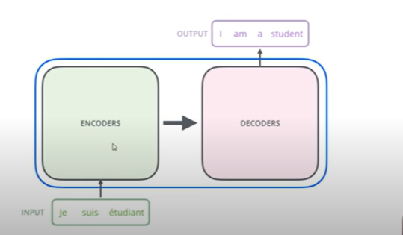

What is present in encoder and decoder

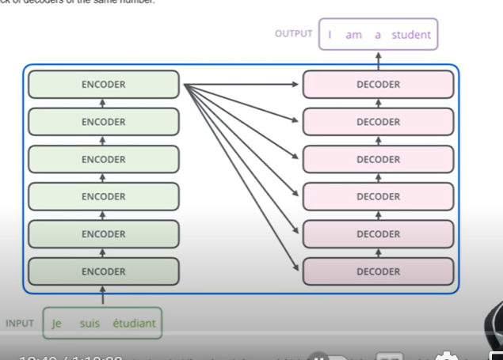

Count of number of encoders 6

Why 6

They have tried with different numbers

But with 6 it gave good result

It’s a kind of hyper parameters

* Final output at encoder given to all decoders

What is there in each encoder

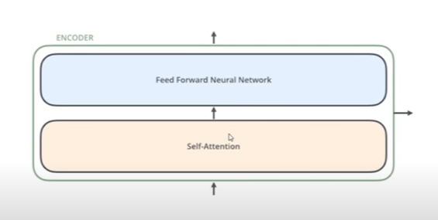

Self attention played very imp role

Self attention:

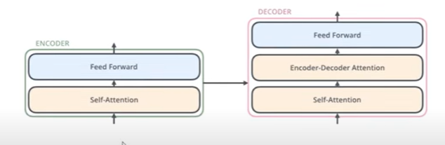

What input is going to encoder

Input text converted to some dimensions using some embedding tech(word2vec)

Vector of size 512(hyper parameter tuning)

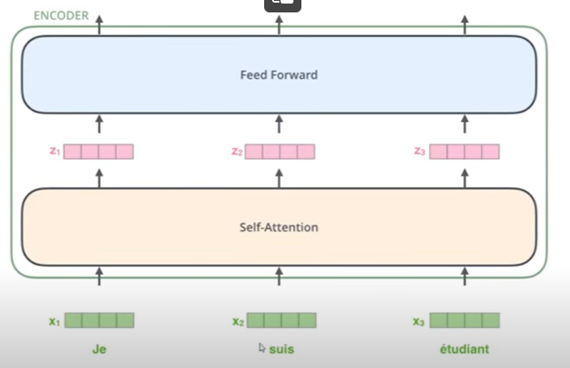

Vector will be passed to self attention layer

This words are not given one at a time like rnn(at different timestamp)

But we are givin all inputs at time

Now use 2 words

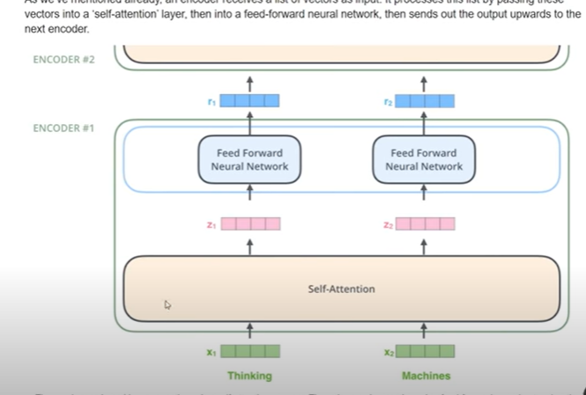

Input words are given parallelly

Now the output of one encoder is going to another encoder

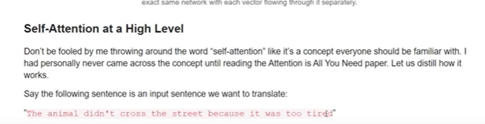

It- street or animal

Based on “it” it will converted to French

It wil be given output – based on “it” refers to

How do we make this algorithm learns

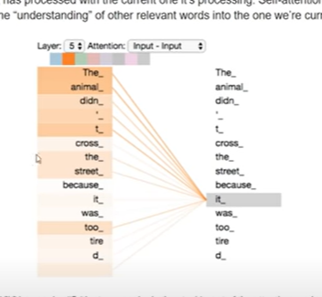

Dark line of lines says – it--given importance to animal

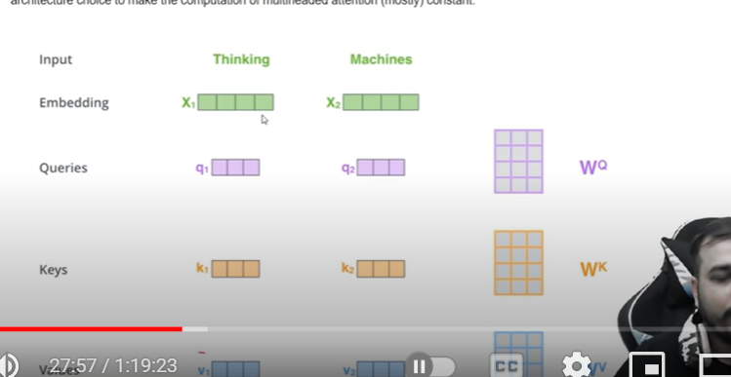

We will be taken 3 weights randomly ( weights will be updated during back propagation)

Wq,wk,wv are weights

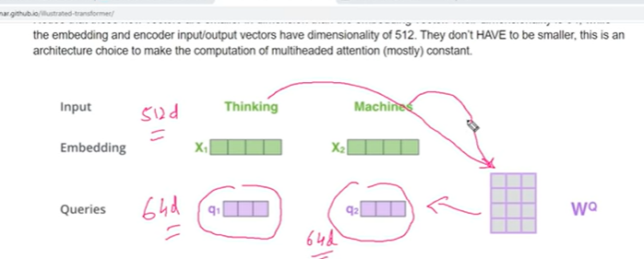

X*wq=q1 x2*wq=x2

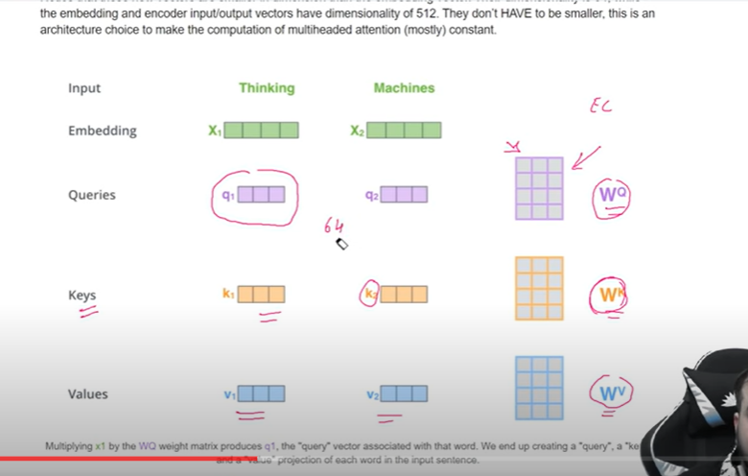

X1*wk=k1

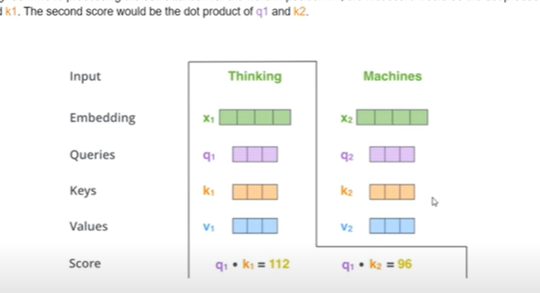

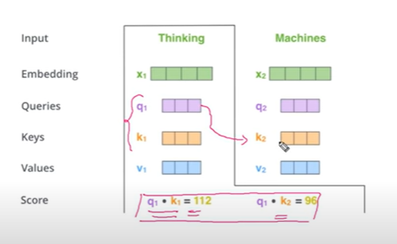

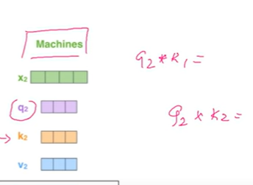

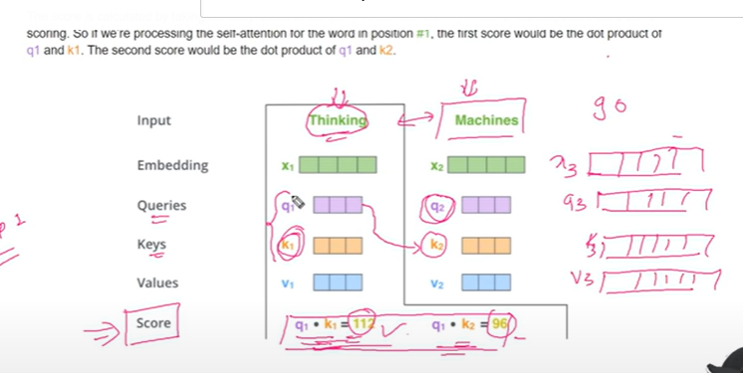

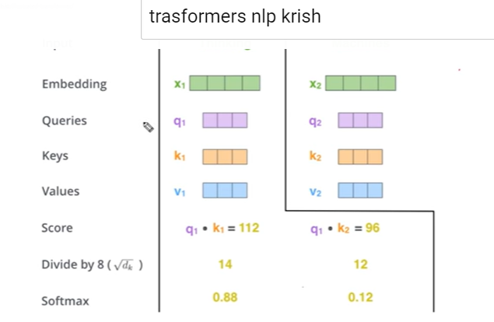

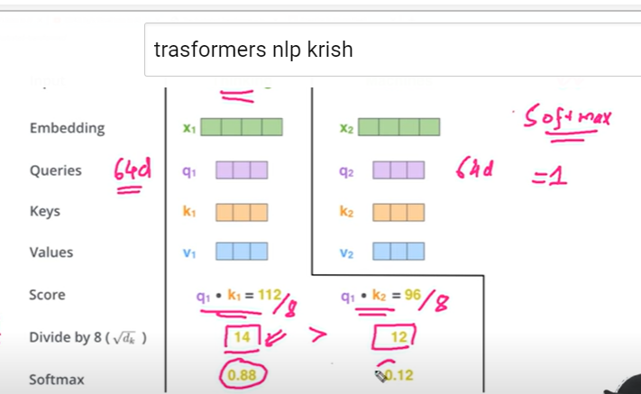

Softmax is we are trying to find probability based on importance of word

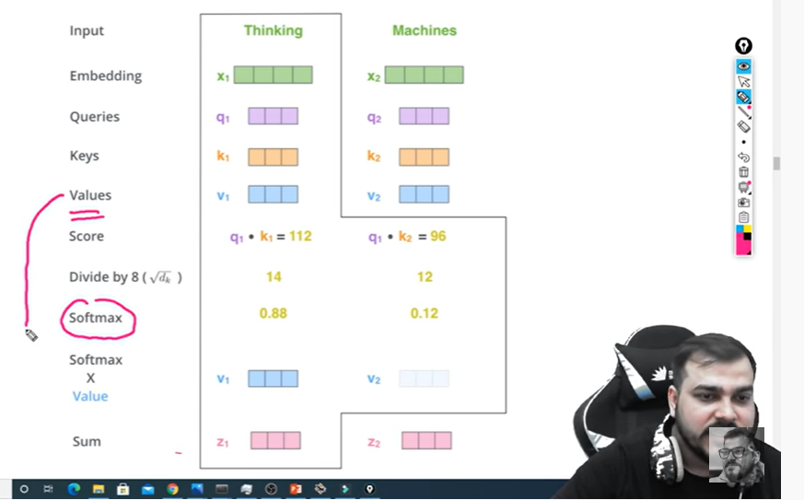

Z1 is output of self attention model

Z2 is output(machine)

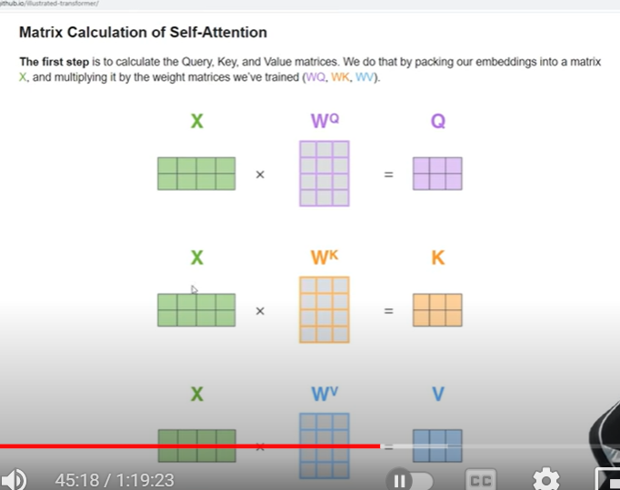

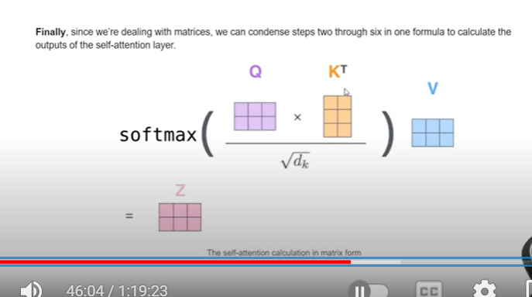

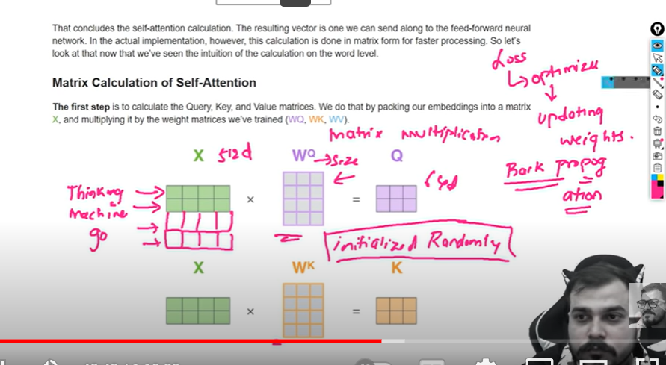

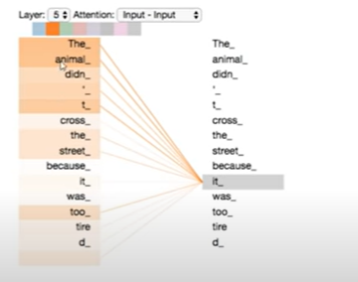

The tired word is so light because we used single weights

For the we need to use multi head attention at different weights

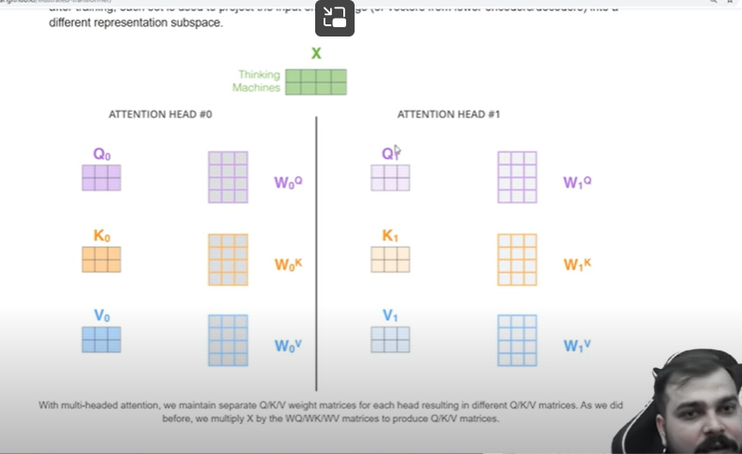

If we used 8 heads we get 8 z values

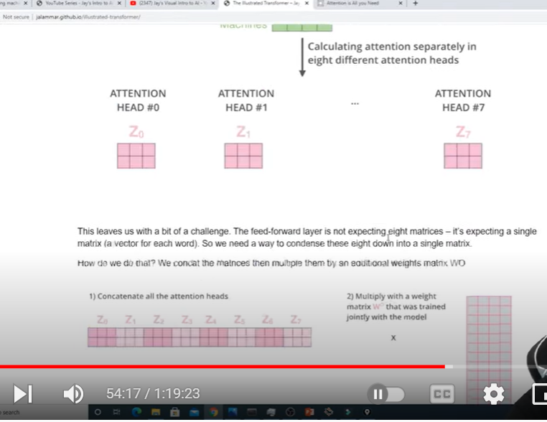

We combine all 8 values

Before passing to feed forward network we need to use another matrix

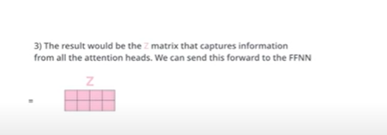

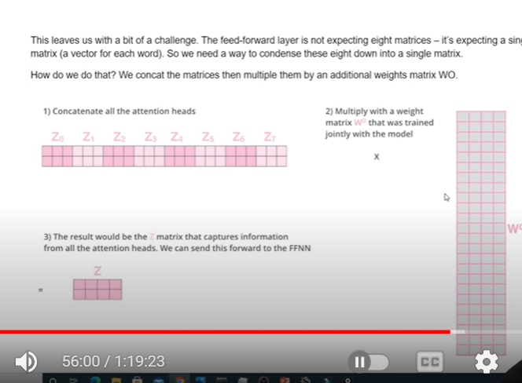

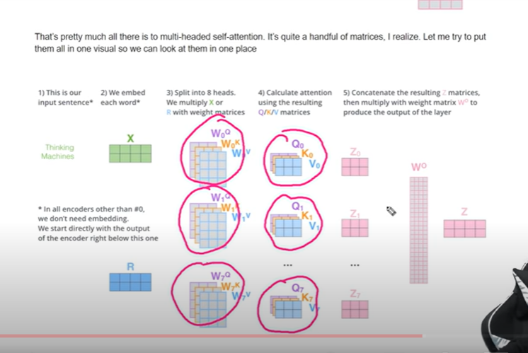

Z will be passed to feed forward network

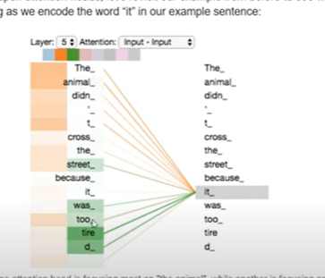

Now both imp words getting highlighted

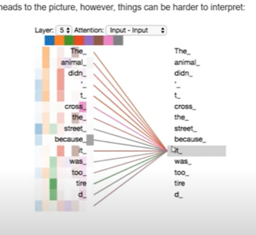

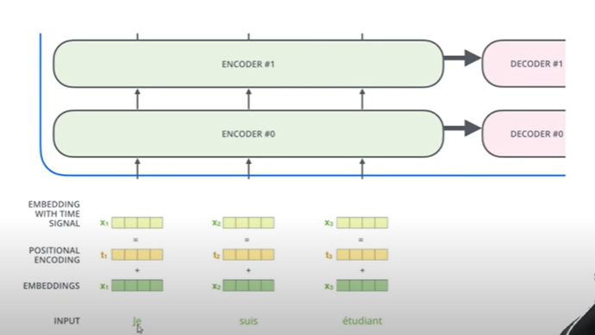

Positional encoding says wether that word is near or not

I eat banana

I and eat are close

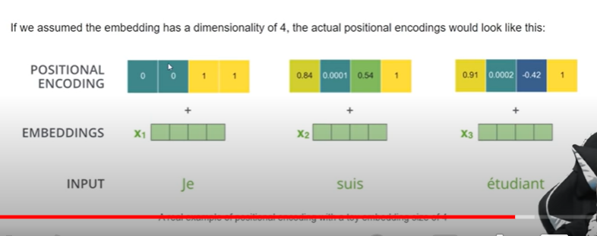

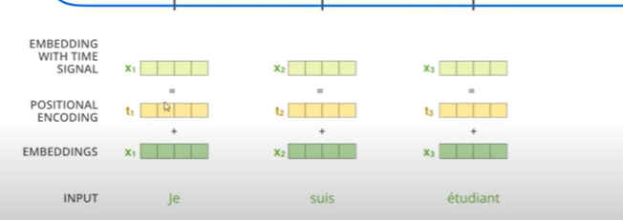

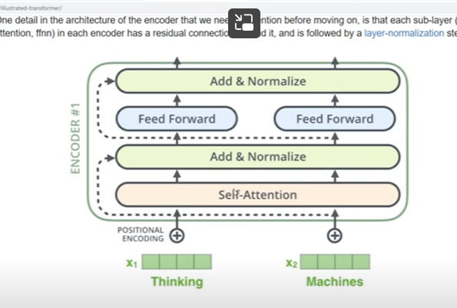

Apply normalization :

Sometimes self attention not playing well the embeddin will directly given to normalize called residual connections

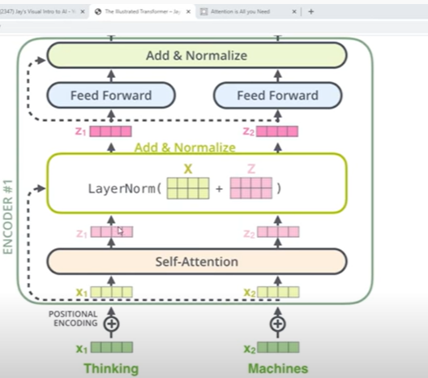

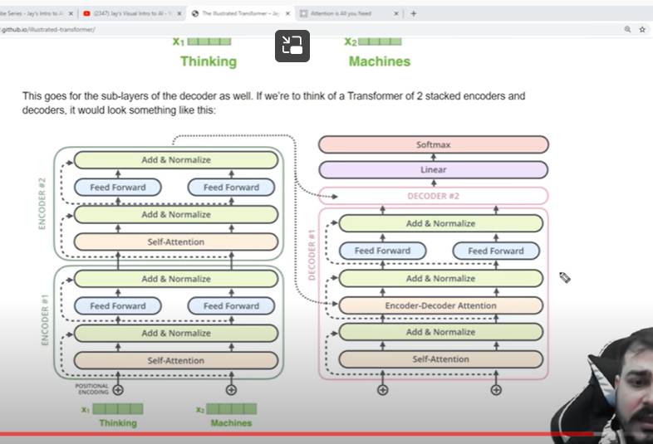

Even to decoder

Self attention

Feed forward

They have encoder-decoder attention (similar to self attention but difference is output of encoder is passed to every layer of decoder)

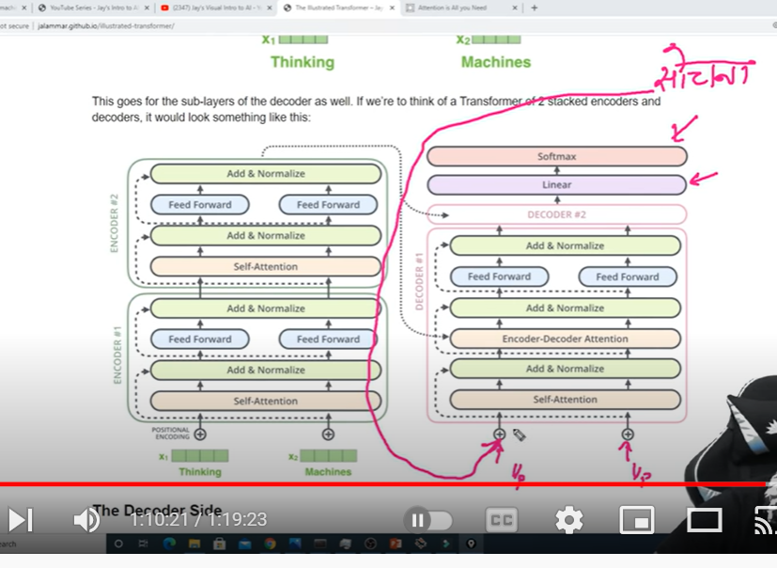

But ouput will be one by one

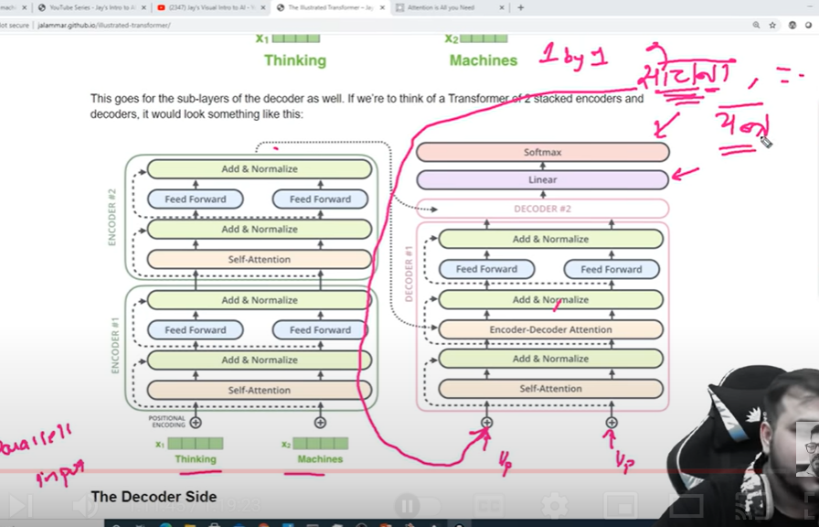

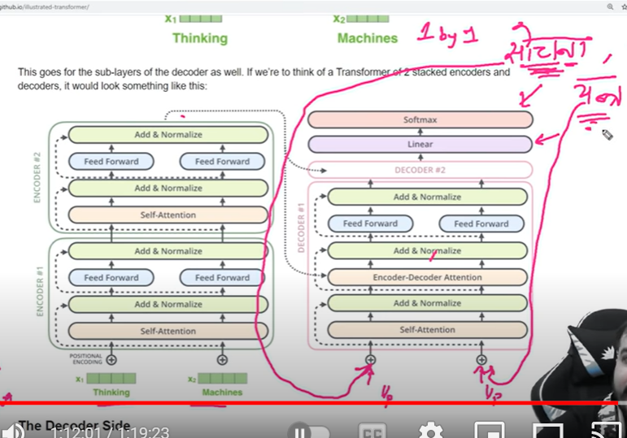

Now two words are responsible for finding 3rd word